Recuperare inizio

Magneto-encephalography

It uses a huge magnet

* very expensive
* Not confortabile
* Very complicated to analyse the data

Few experiments actually used is

Transcranial magnetic stimulation (TMS)

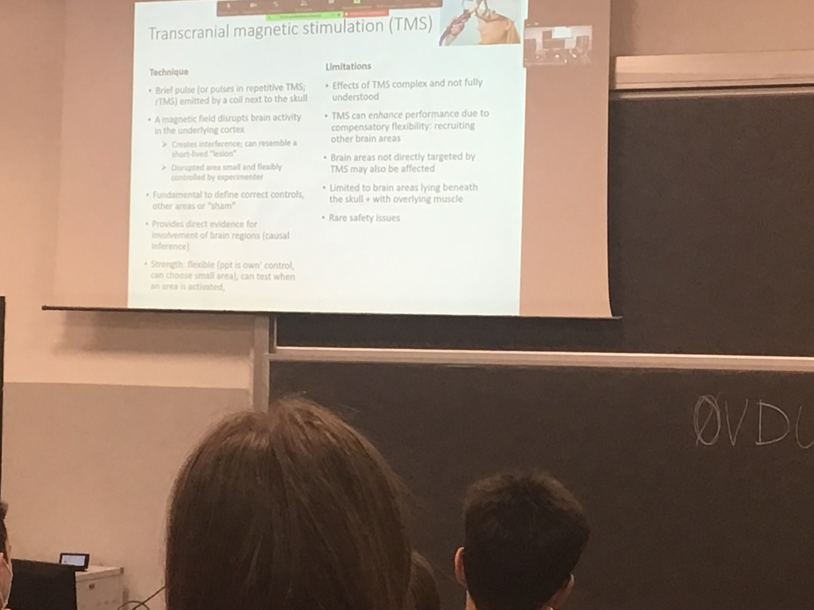

Is a new technique, use a magnet.

The magnetic field Emi teeter from the coil creates an interference in the brain cells. Simulate a lesion, block activity in a specific position, create a short time lesion. Repeat experiment with and without the TMS to see which devices appear (can’t move hand…)

Use the correct controls, use double dissociation to decide that an area is important in a specific function you should do two test:

* TMS in that area. Show that it going to interference with the task
* TMS in another area

Usually there is a third control (sham control) that makes a lot of noise. Provides evidence for involvement of the brain lesion. And we can test areas while they are doing a specific task.

Sometimes the action makes me better in some tasks (not fully understood why). Can be applied only to some specific area (can’t go in the area between two empires). People with epilessia sometimes the TMS start epistles seizure. First thing is to test epilessia.

**Cognitive neuroscience**

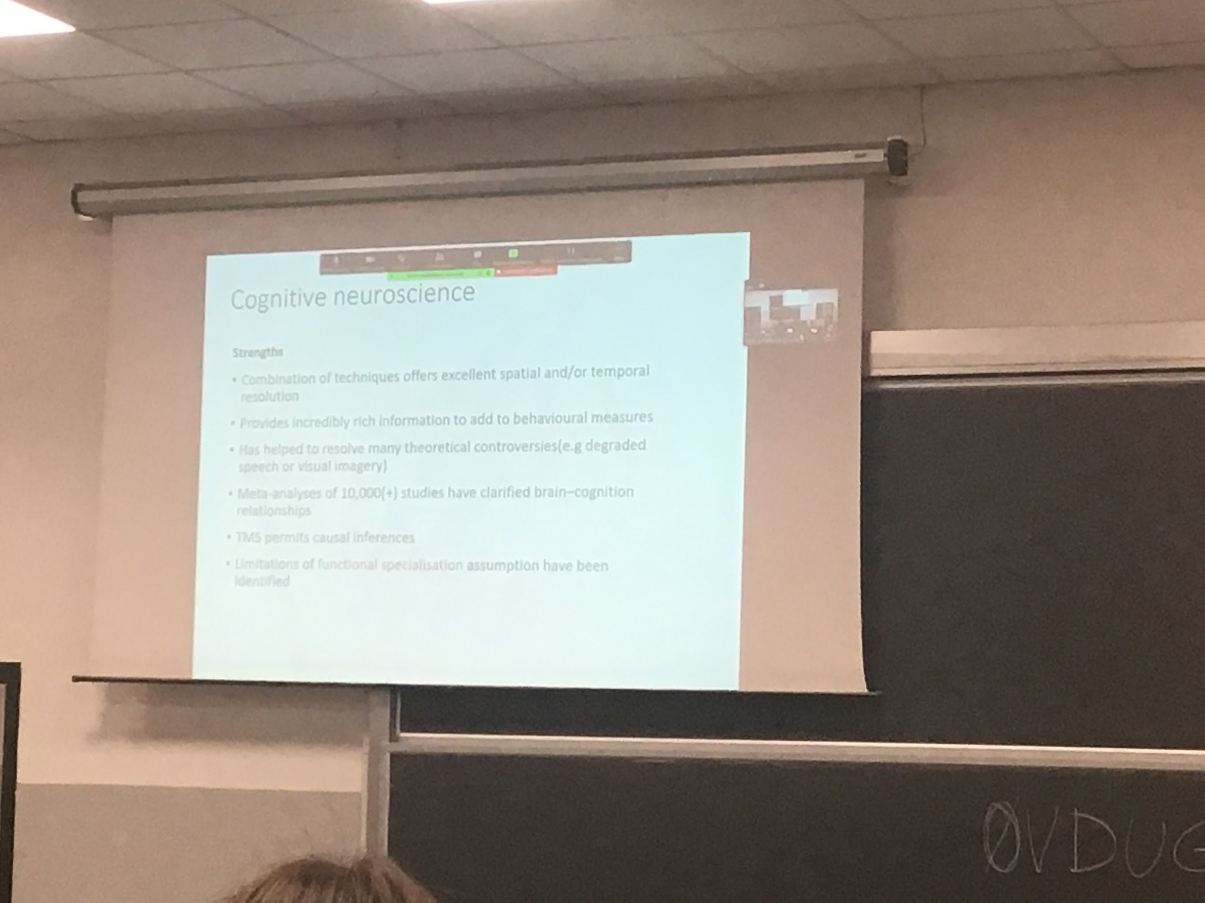

All the techniques if we see them together they offer excellent spatial and/or temporal resolution

They allow us to associate to behaviour brain activity.

Visual imaging:

We can recreate in our mind an image of a place where we have been, is not imagination, we create a specific environment. This is visual imaging. Visual imaging is a recreation of the same computation that the brain does when we are actually looking at our room. Huge debate between if it is a recreation or if there is no brain activity dedicated because is reasoning. The answer is that is a mixture of the two

Single studies sometimes can report results that come out by changes (depending on how you put your level in statistical analysis) now up information all together from a lot of analysis and check what is recurrent. There is some specialisation in brain area.

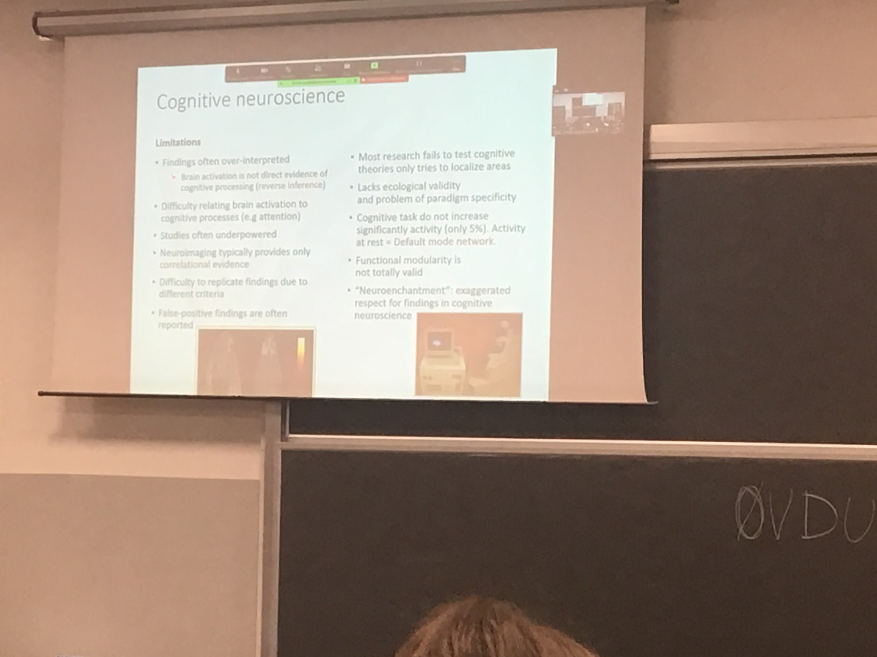

Sometimes the results are too stressed. We need to repeat the test many times, having an area of the brain active in a specific task (if the task is complex). There are functions

We have to be careful. Is easy to find activity in random situations.

5% maximum difference of real activity. The brain is always active, even if we are not doing anything the brain is still communicating. The brain is always working when there is increased activity there is modularity. Different area do preferentially some kind of task but also do others task

The default mode network is when technically the brain is thinking at nothing. Doing technically nothing. But if there would be no actual activity we would be dead.

The way to see if someone is dead is to check activity in the brain. Even in coma you can register activity in the brain

We must be careful to give to this finding too much weights

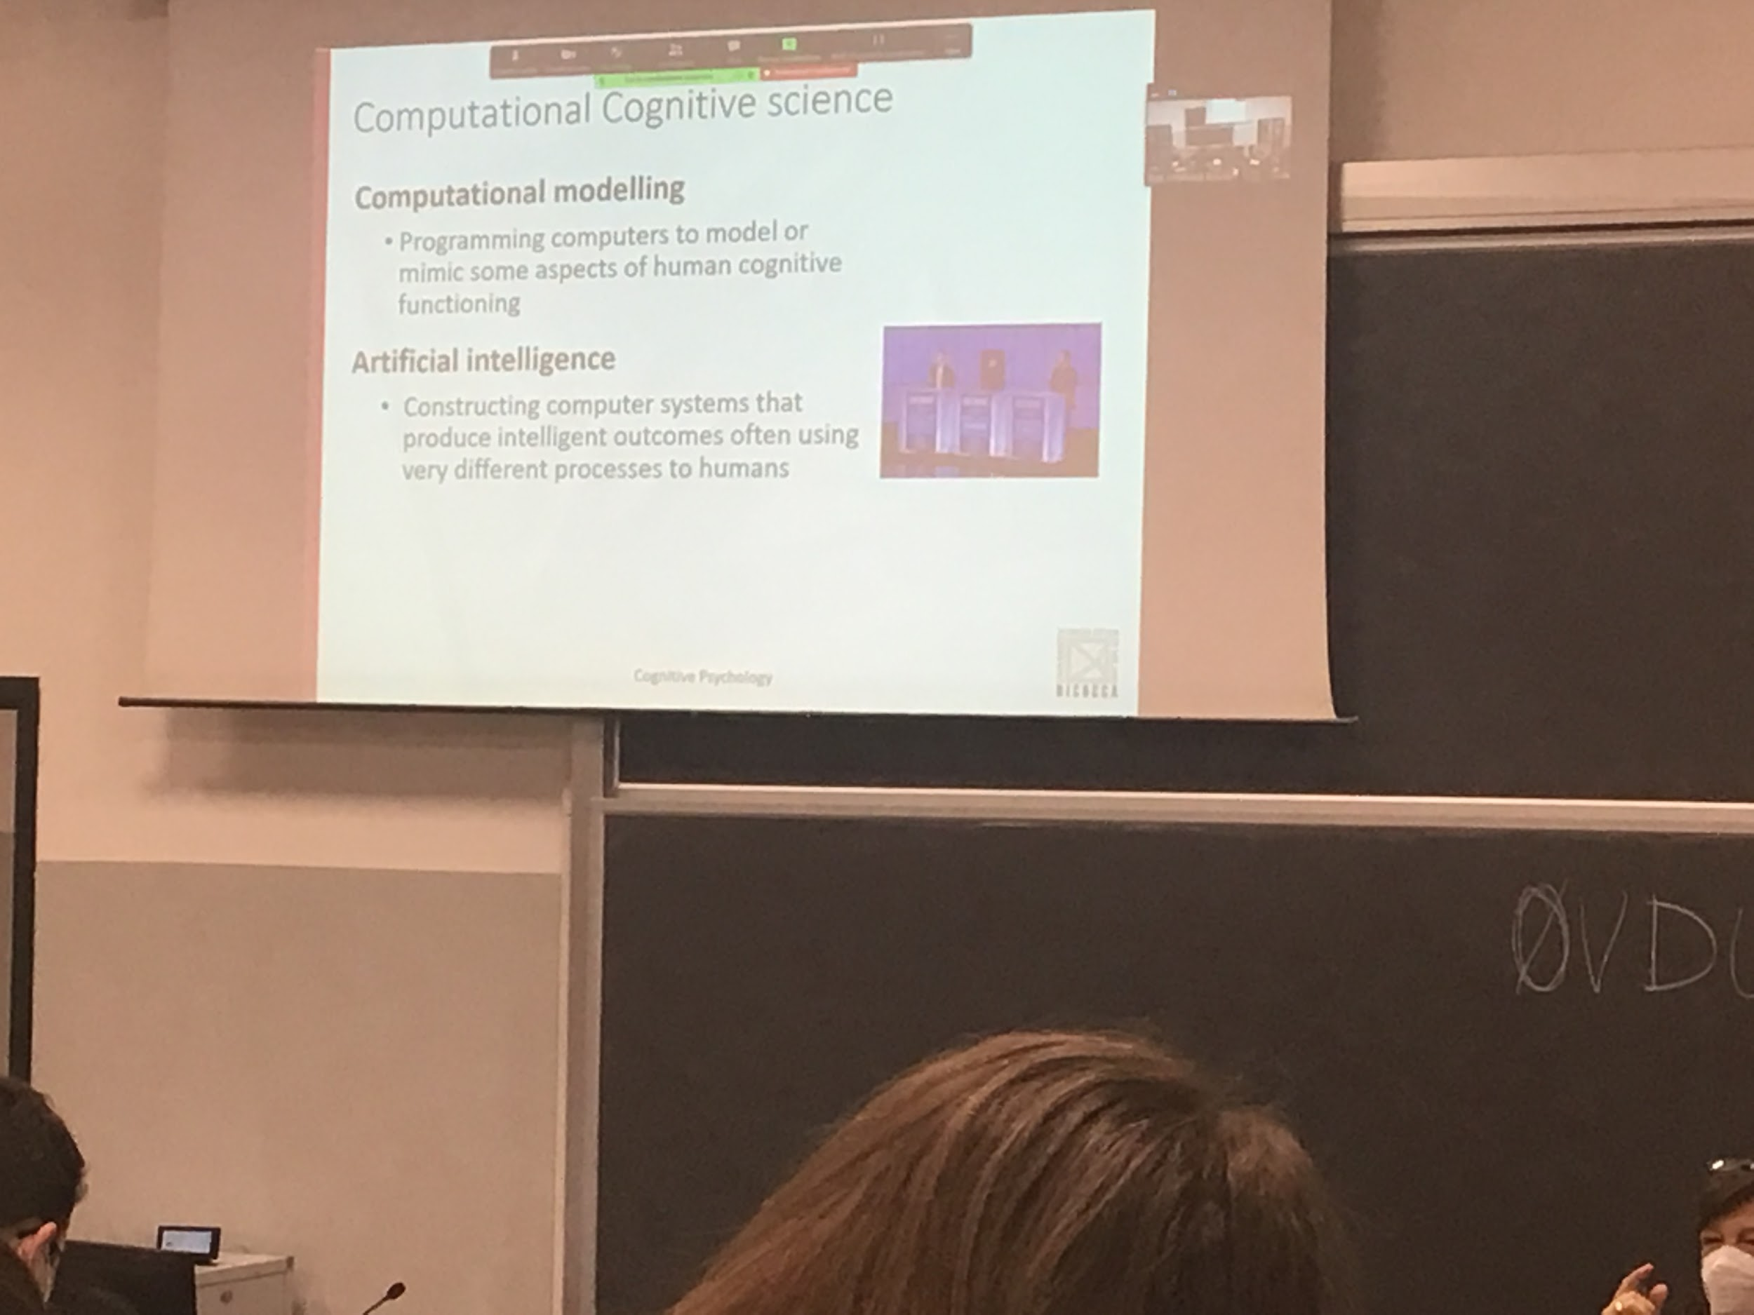

Computational cognitive science. Is a link with AI what we try to do is to produce theories how the brain works. In the past it was difficult to test, not needed a real specification of the theory. Computation models force specific even the smallest details. Forced to be very specific. Is the way to program computers. The difference with AI is that it wants to create something intelligent. Have a task and want a computer to do it in an intelligent way.

A dedicated program that does a specific thing can be better than a human. But the brain has to do multiple things together. It has to put together different requirements. Can not recreate a machine as good as our brain (up to now).

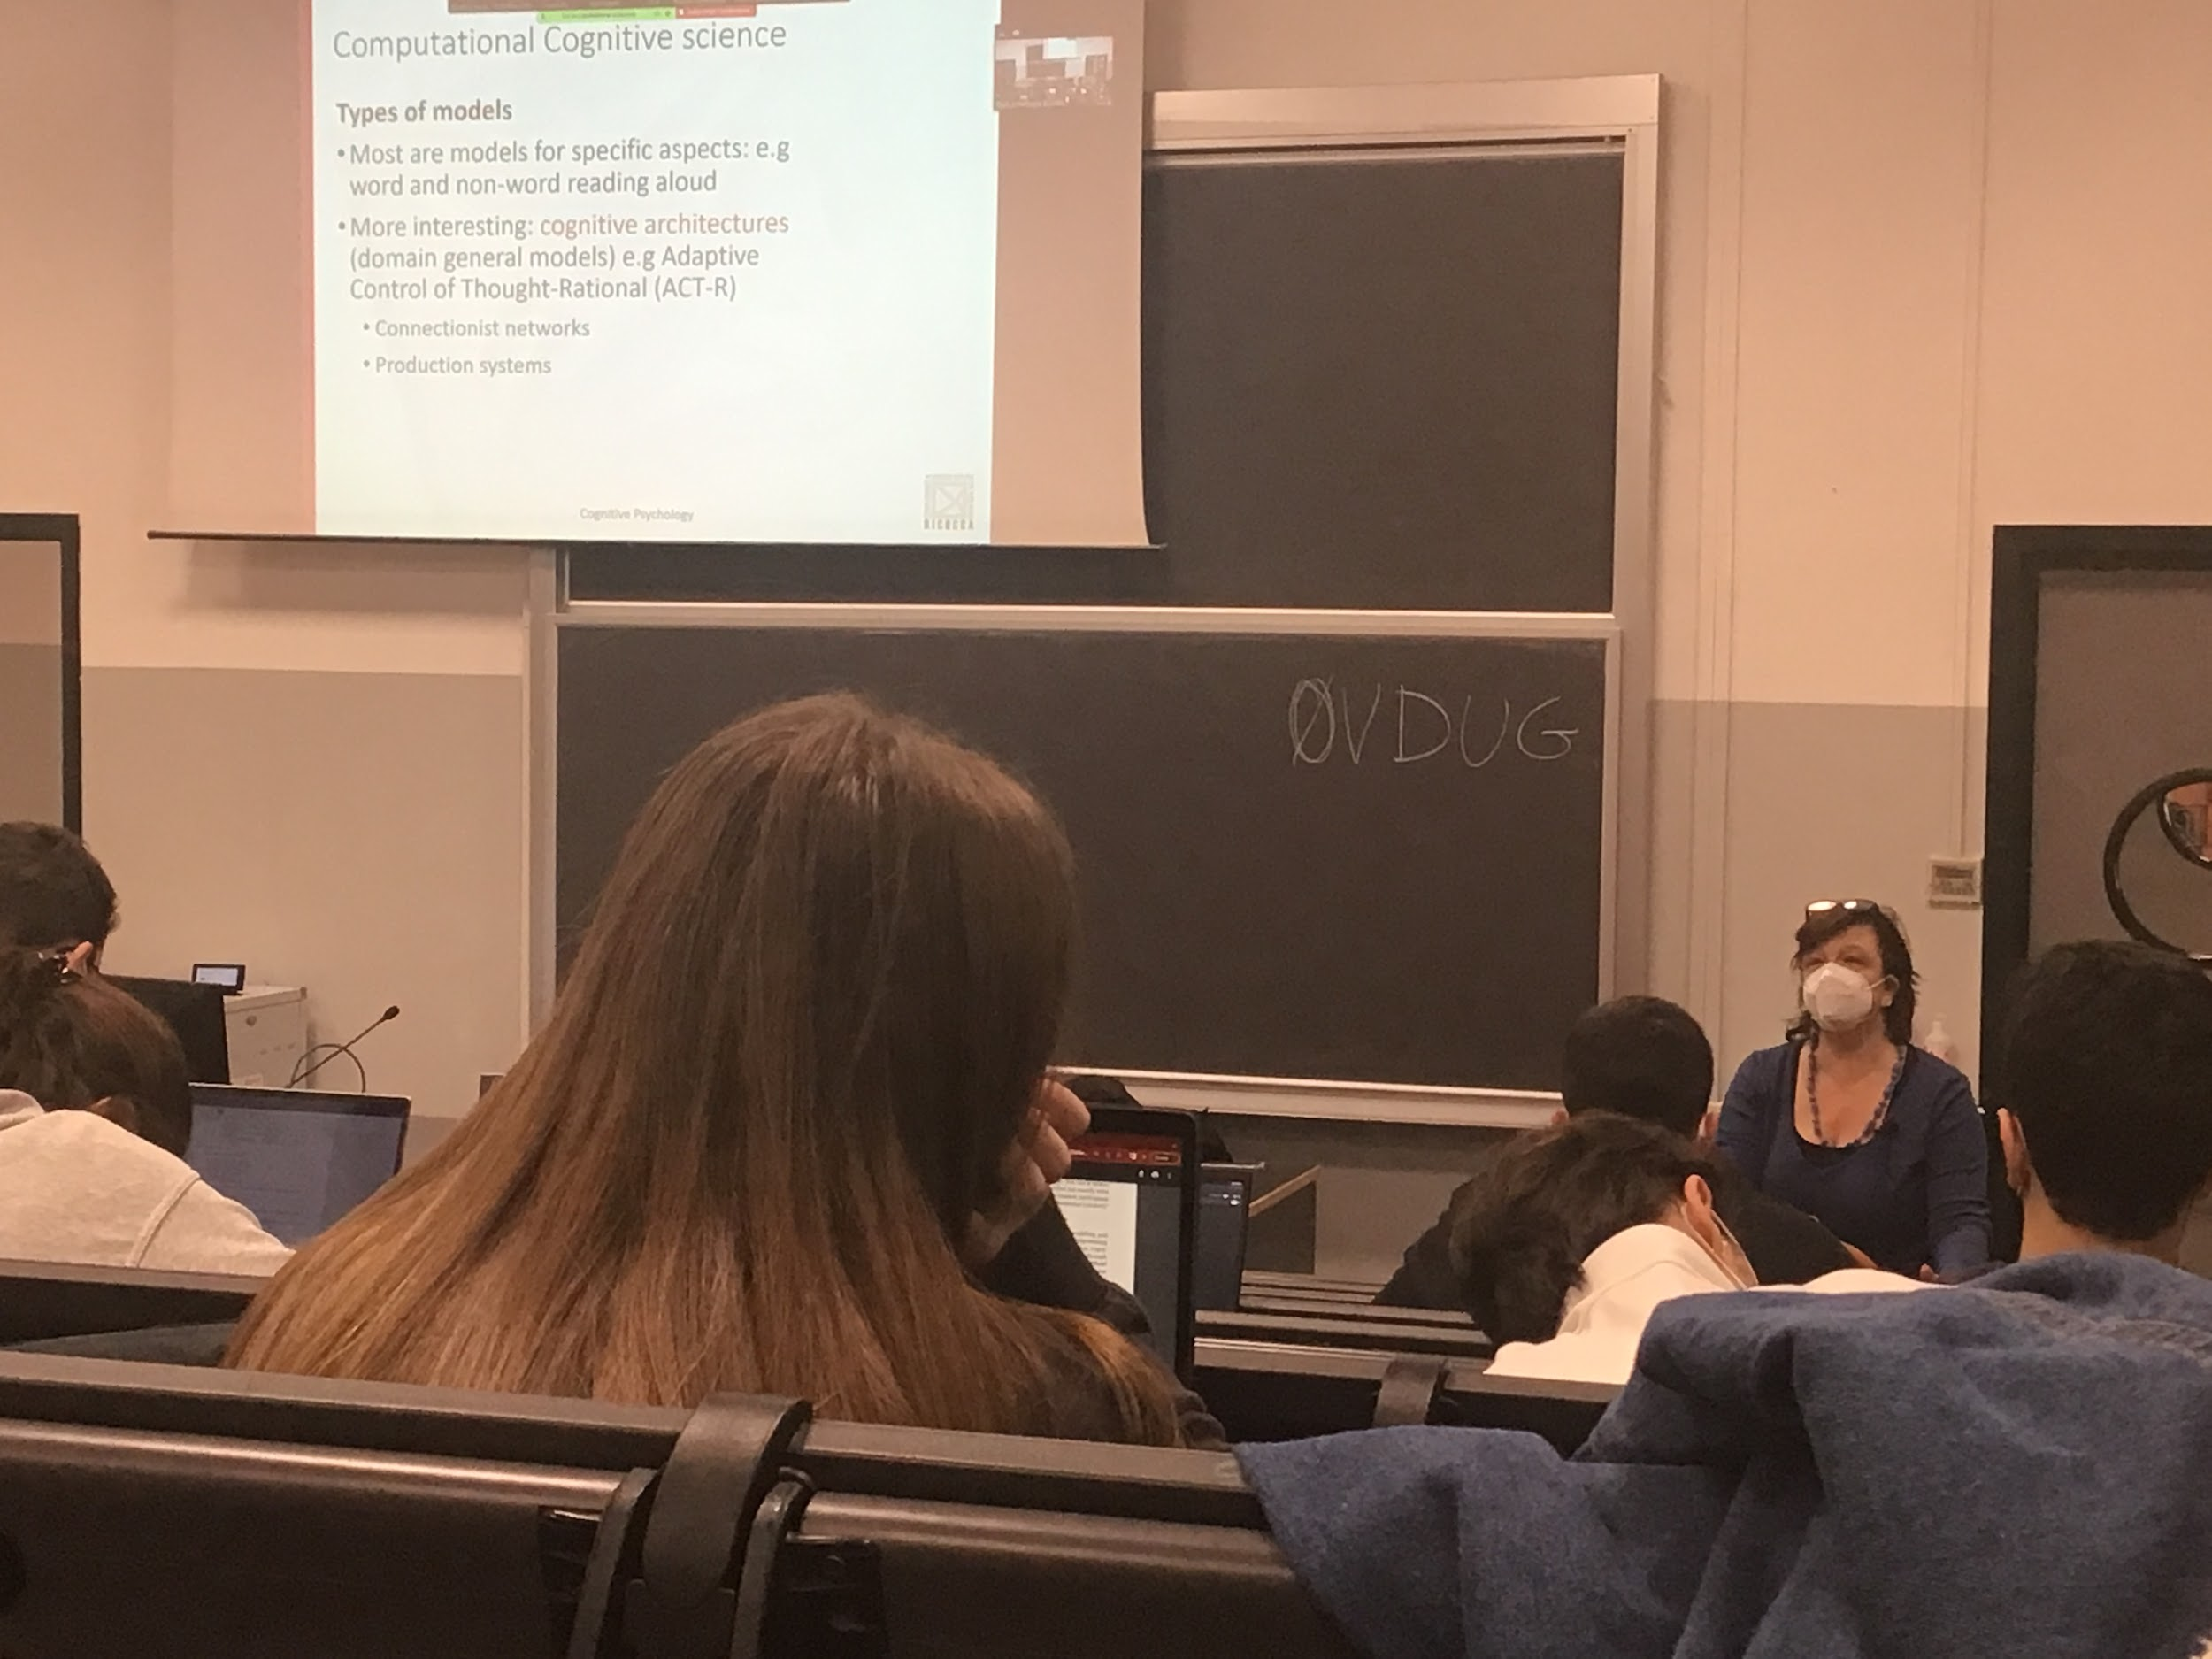

We create a program, give a program a lot of examples and the PC needs to reproduce the mistakes.

We are far away from creating a domain general model. That reproduces many different functions. That does not only reading but also do different task.

Most known ACT-R model used to reproduce perception, tension, reasoning, memory…

A production system is like a program. Rules like *if … then …*

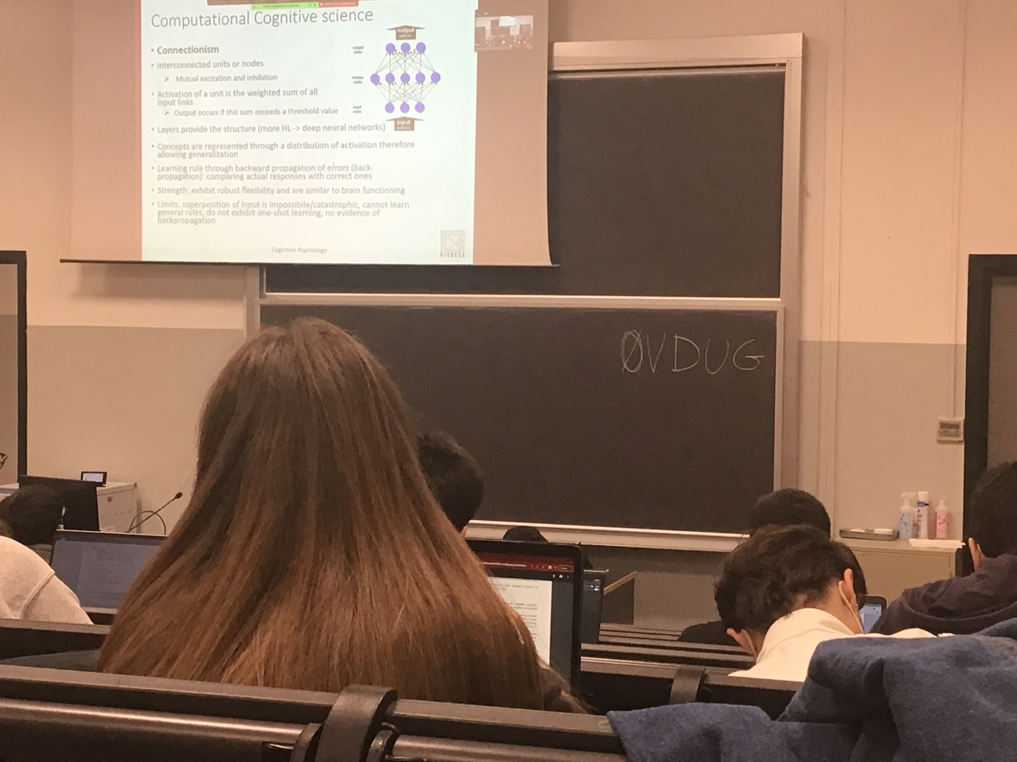

Simulate brain activity. Brain is made by a lot of neurons. What emerges in the end is made by. Computation of lot of nears

Usually the neuronal network is made by different layers. There is one input layer, at least one ideen layer and an output layer.

The units are all connected (usually in 1 direction) from the input to the output. Can be excitatory or inhibitory.

Activities depend on the information that receives from all the neutrons at the previous level.

More layers can perform many tasks.

Correct the connections

Neuronal networks generalise it. If you take a word that is not in the 100 studies it will be classified correctly (most of the time).

When we see a new model of a chair we know it is a chair, even if we didn’t see it before. We know what characteristic a chair have

There are some limits, can give at the same time multiples input

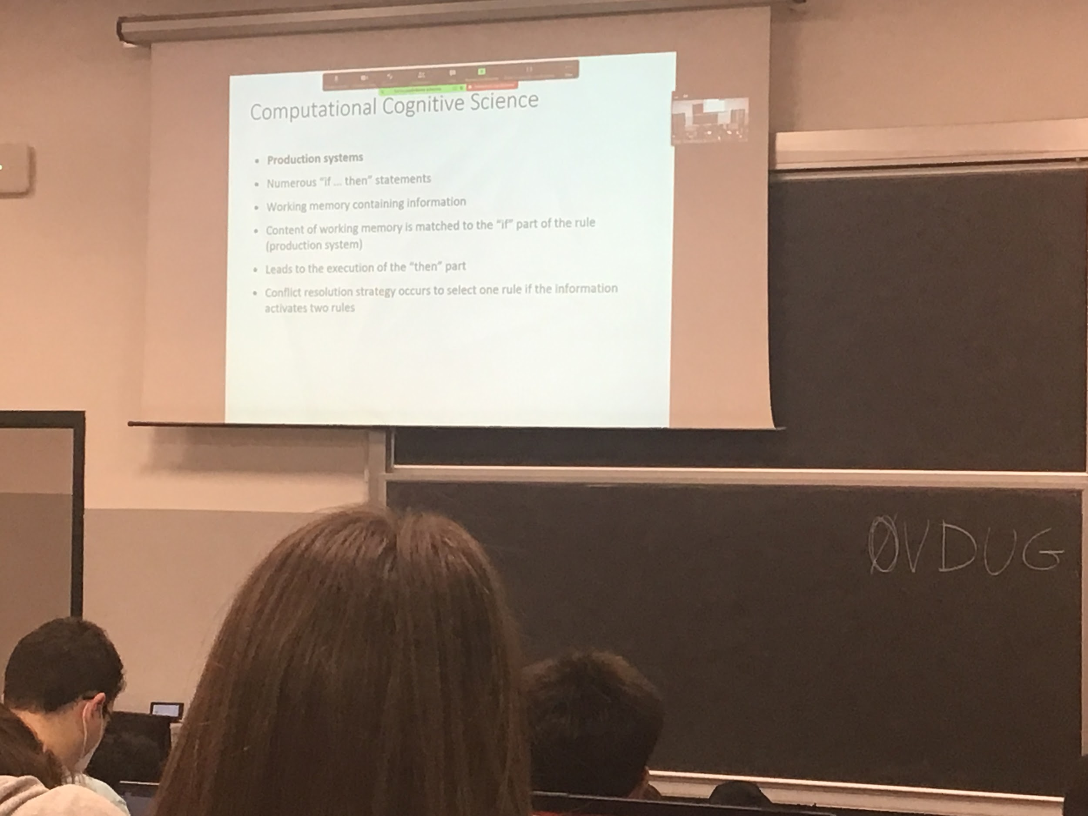

Production system made by multiple production rule

A production rule is a very simple *if then* statement. Can have complex rules as combination of conditions

There is some kind of memory that contains the actual state of the system.

The information is check in the *if part* then if is correct the *then part* is applied

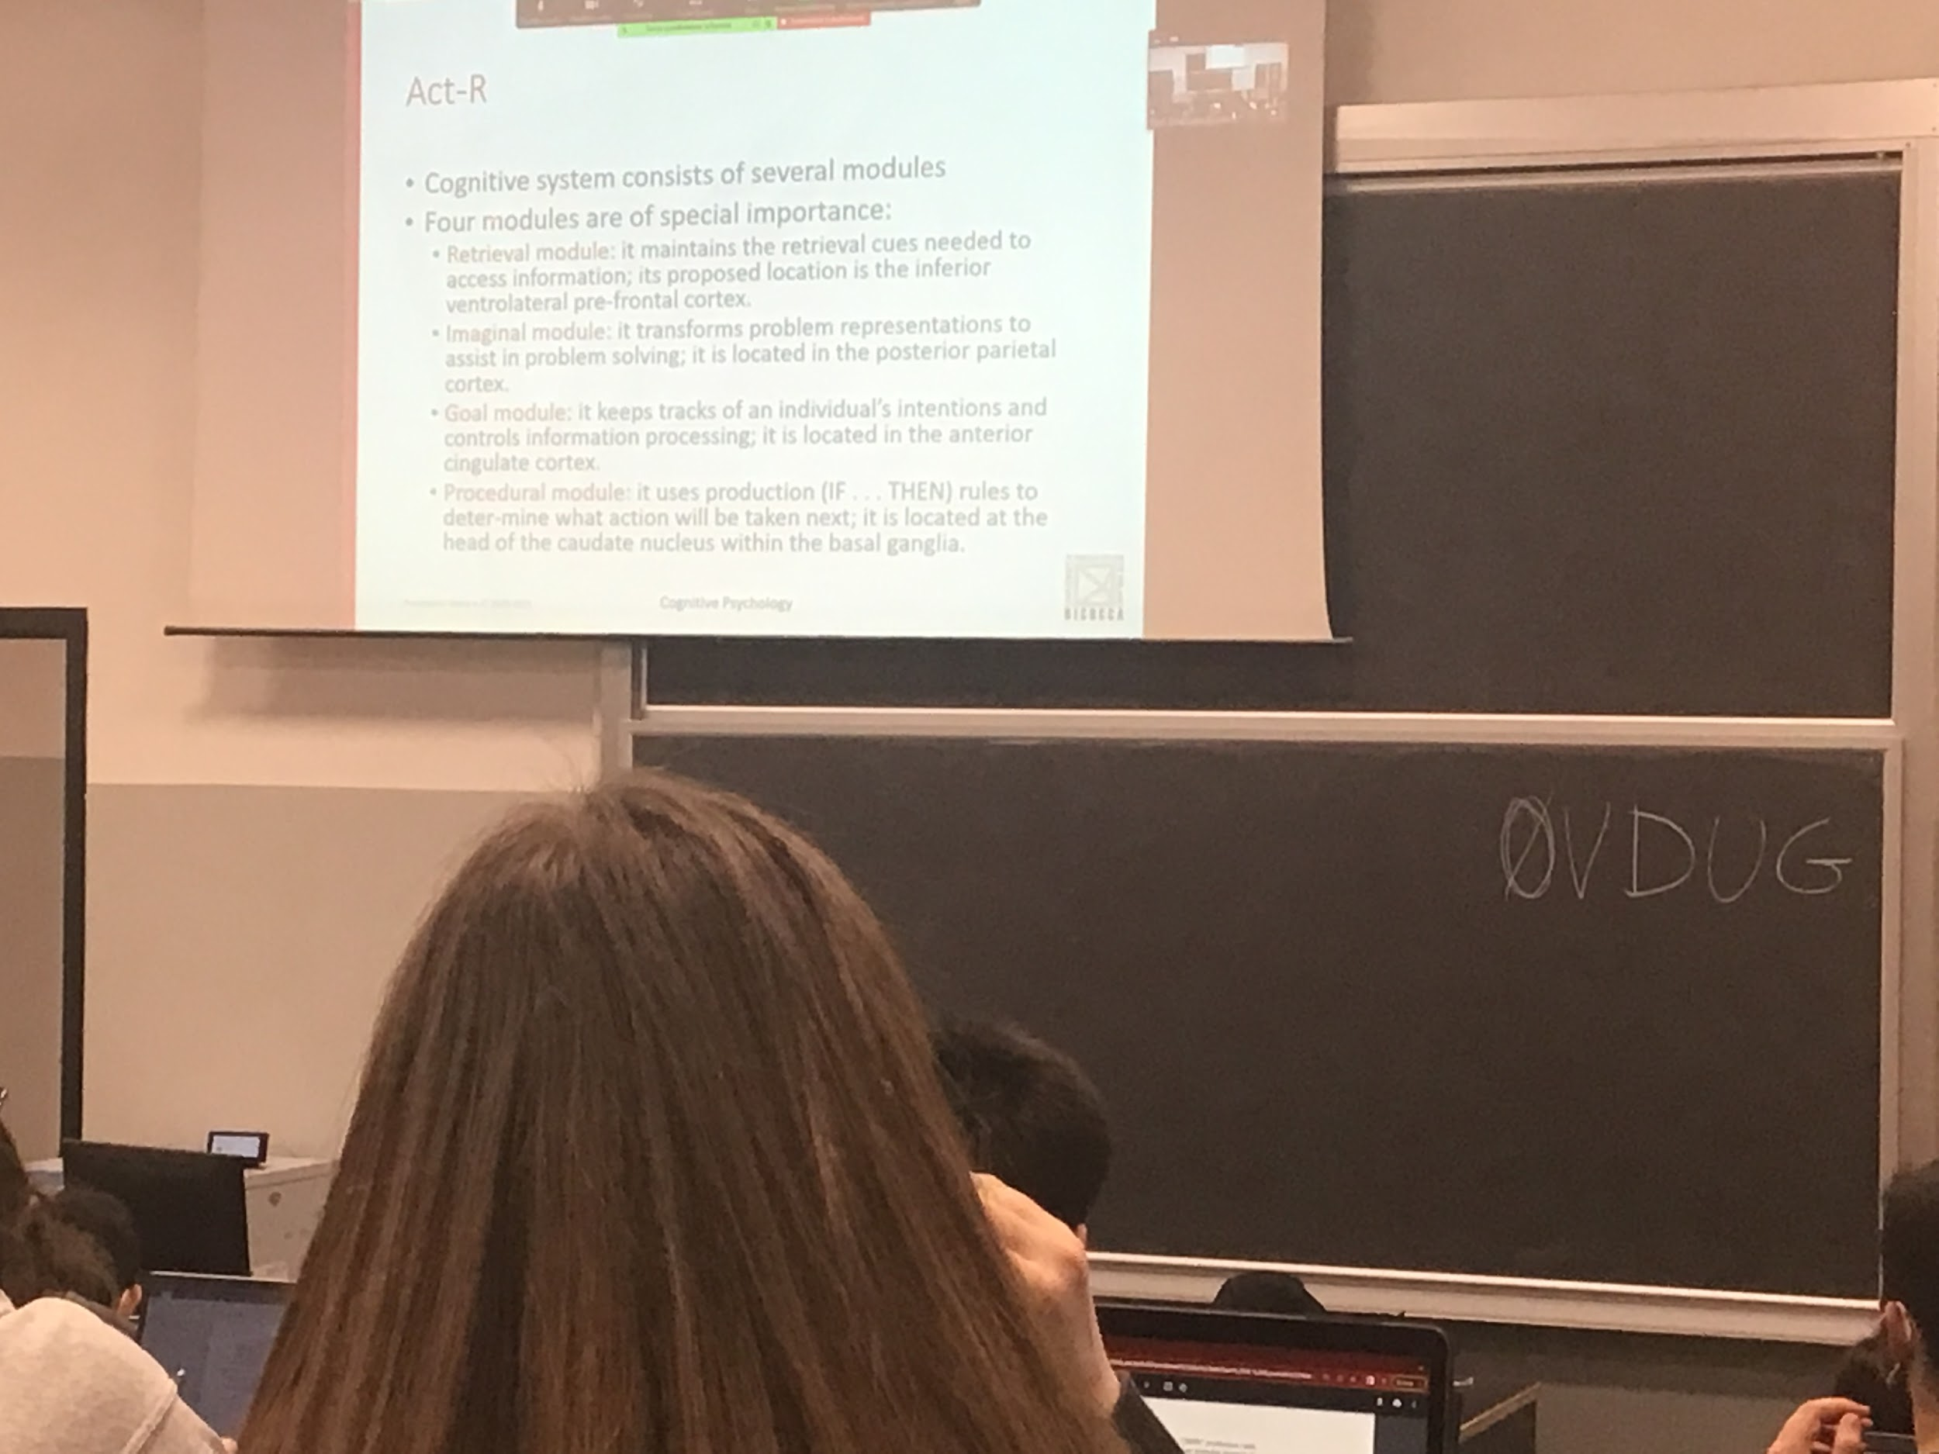

On so that importal model is act-r

Is a general model because it gives modules that simulates different part of the brain, allows to reproduce different tasks

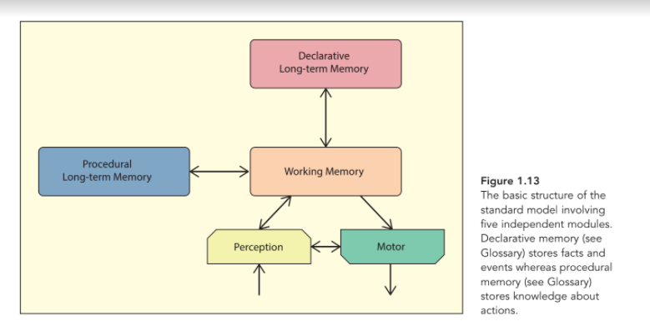

Information that comes from the outside that is analysed from the sense (perception). We perceive what is out there. Representation of what is outside.

Working memory: is the information of what I am conscious of now. The working memory interacts with the declarative long-term memory

Declarative long term memory. We have storage what we learn in our lifetime, the meanings of the words….

Procedural long term memory. Like how to write… is a motion time of memory.

All the informations interact and you decided to perform a task and your your motion system to perform the task

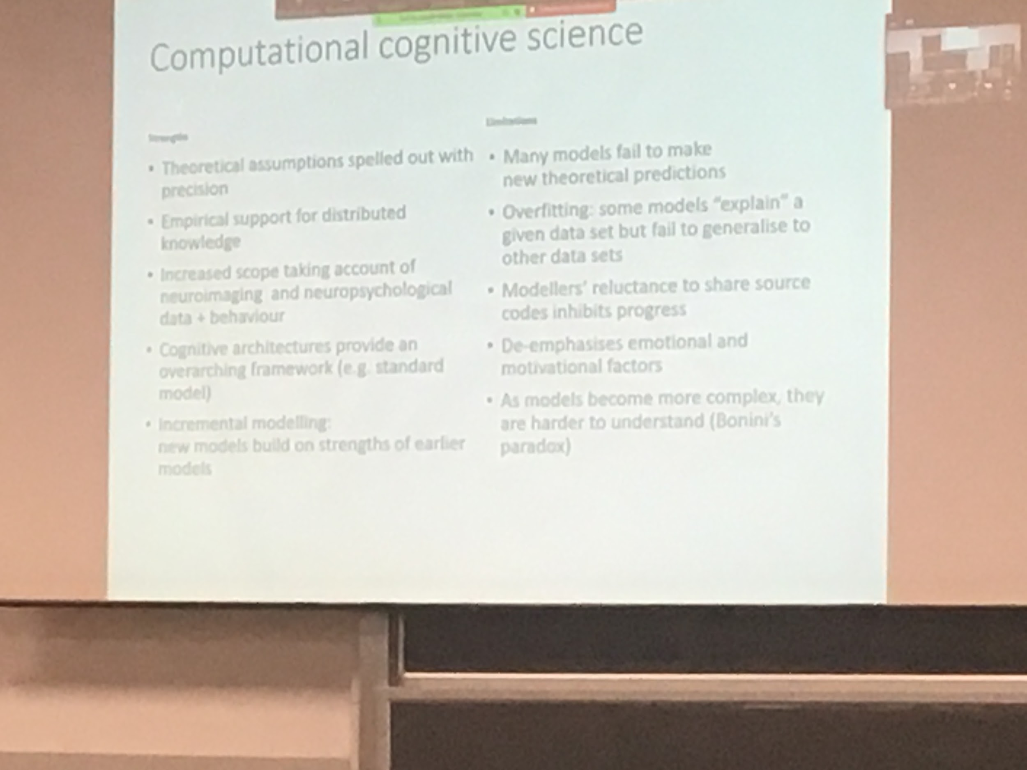

The advance of computational neuroscience is that we spelled out (spiegato) with precision the theoretical assumption

We store information in our memory. help us predict different situations. Declarative long-term memory: *What is the capital of Italy?* You can tell me precisely the answer. The procedural long-term memory is like: *how to ride a bike*. Can not tell me exactly how to do it.

Experimental cognitive psychology. All computation modelling is proposing, each one of us has the possibility of learning something different. Only together we will improve the knowledge how the brain works

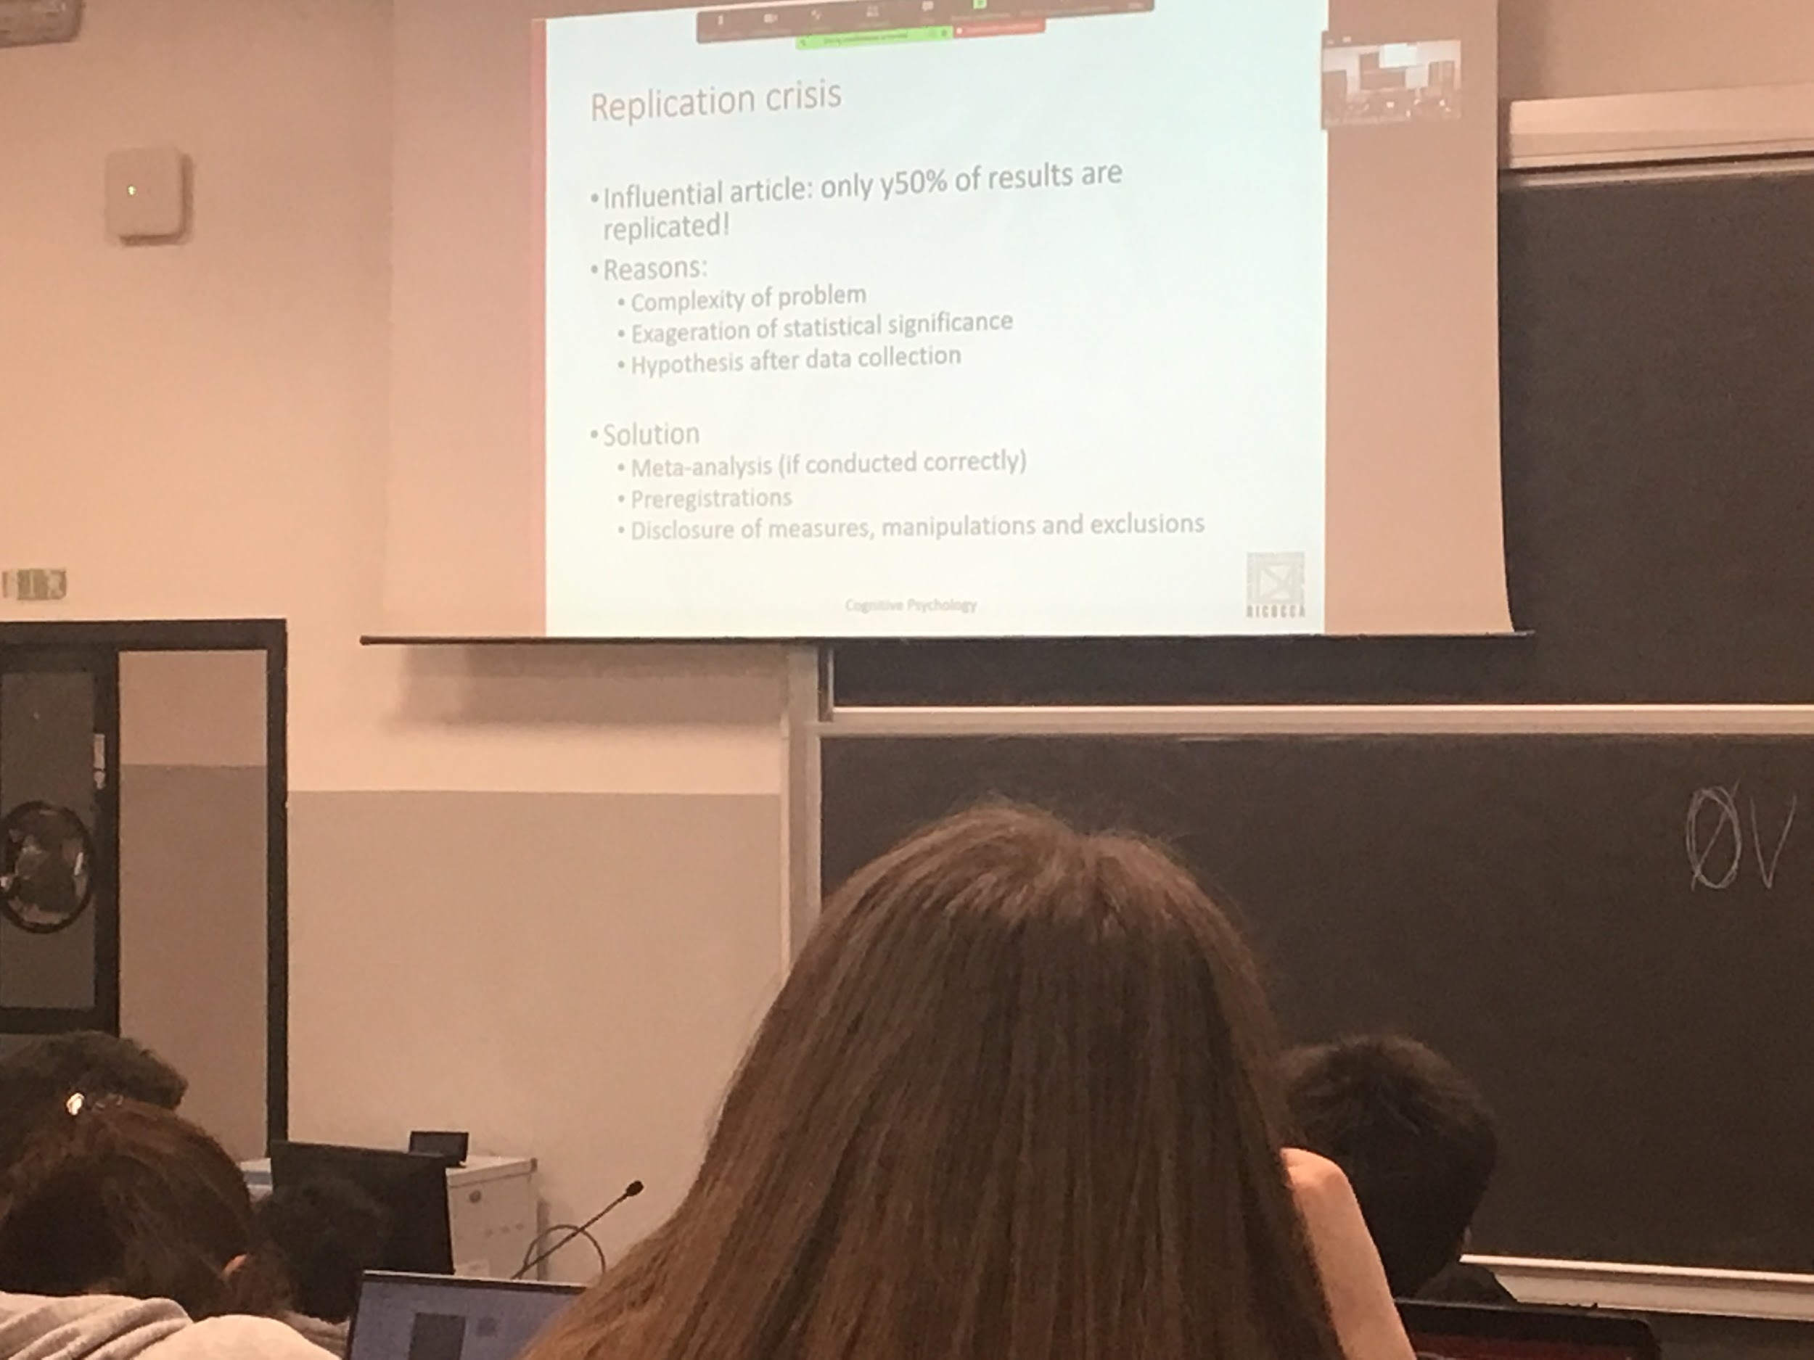

Only 50% of the results of cognitive psychology are reproduced. The problem is due that even very small changes induce people to perform differently.

Be able to actually not only publish the results of the data but publish all the data that we used to get the result.

Using differential analysis provides different results. Be careful of data produced by psychology’s. We should wait to see if the test is reproduced. The 50% replicated are very strong results.

**End of first chapter**

# Chapter 2

BASIC PROCESS IN VISUAL PERCEPTION

Information coming from the outside from ears, taste… information that our muscles give to our brain. More than 50% of the brain is dedicated to vision, creating a representation of the environment when we are. Most books work on visual perception

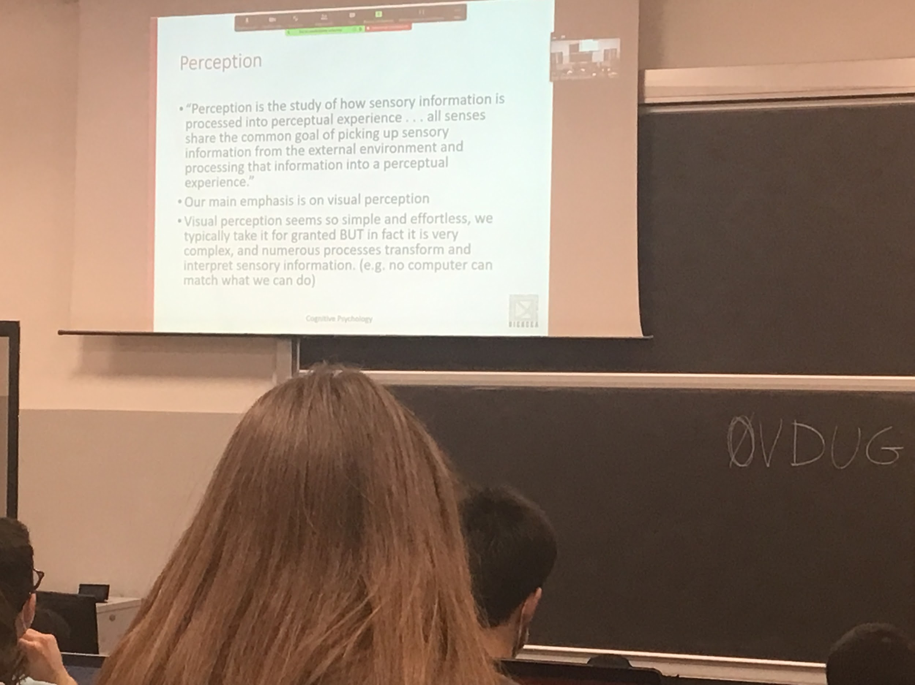

Information is produced in the environment in some kind of energy. Light.

Light is the envy that pervades our environment and arrives to our eyes. Our senses detect the presence of this energy and transform it to neuronal energy?

Different aspects are coded in different ways and we reach a mental representation of the environment.

Visual perception pervasive light.

We will try to understand what are the different prices of this kind of information

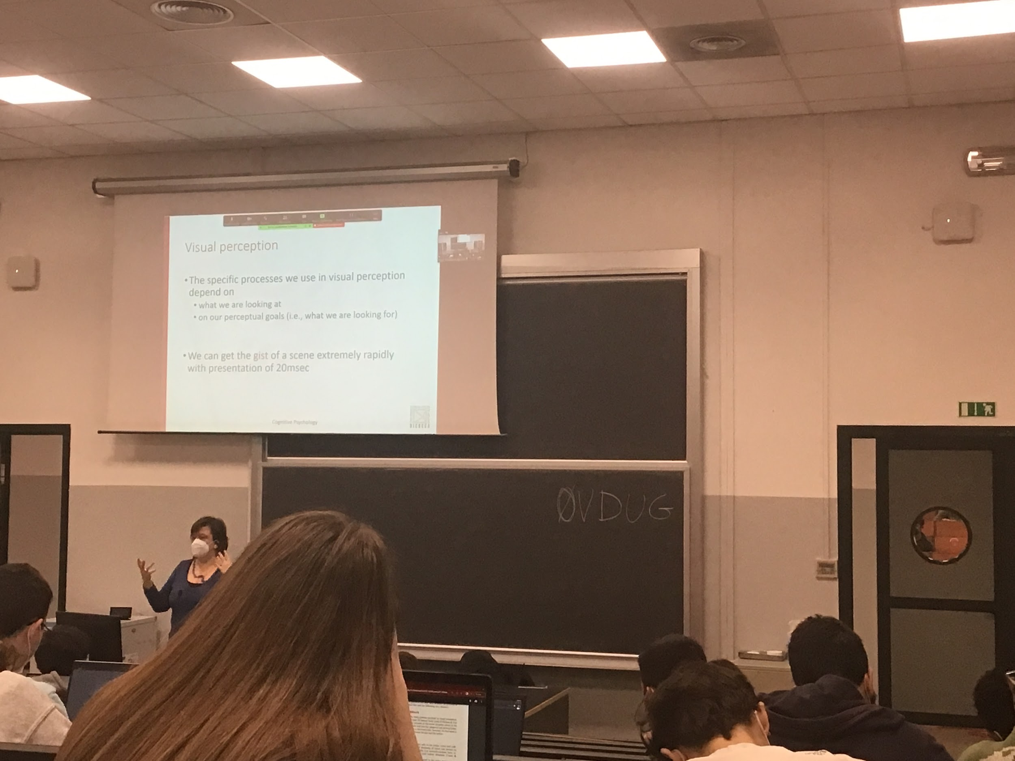

There are different levels of perception that takes different amount of time.

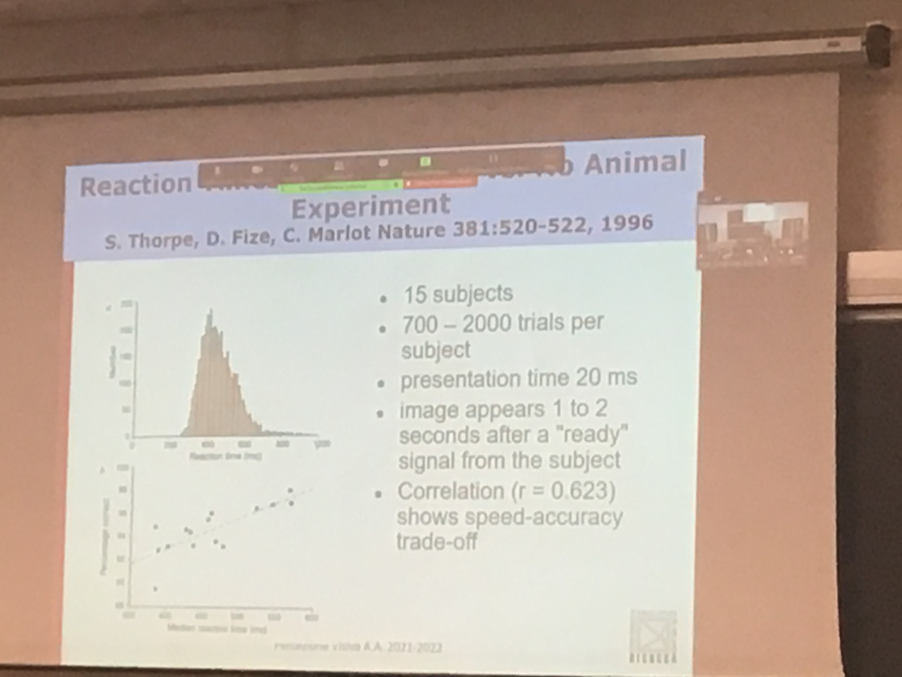

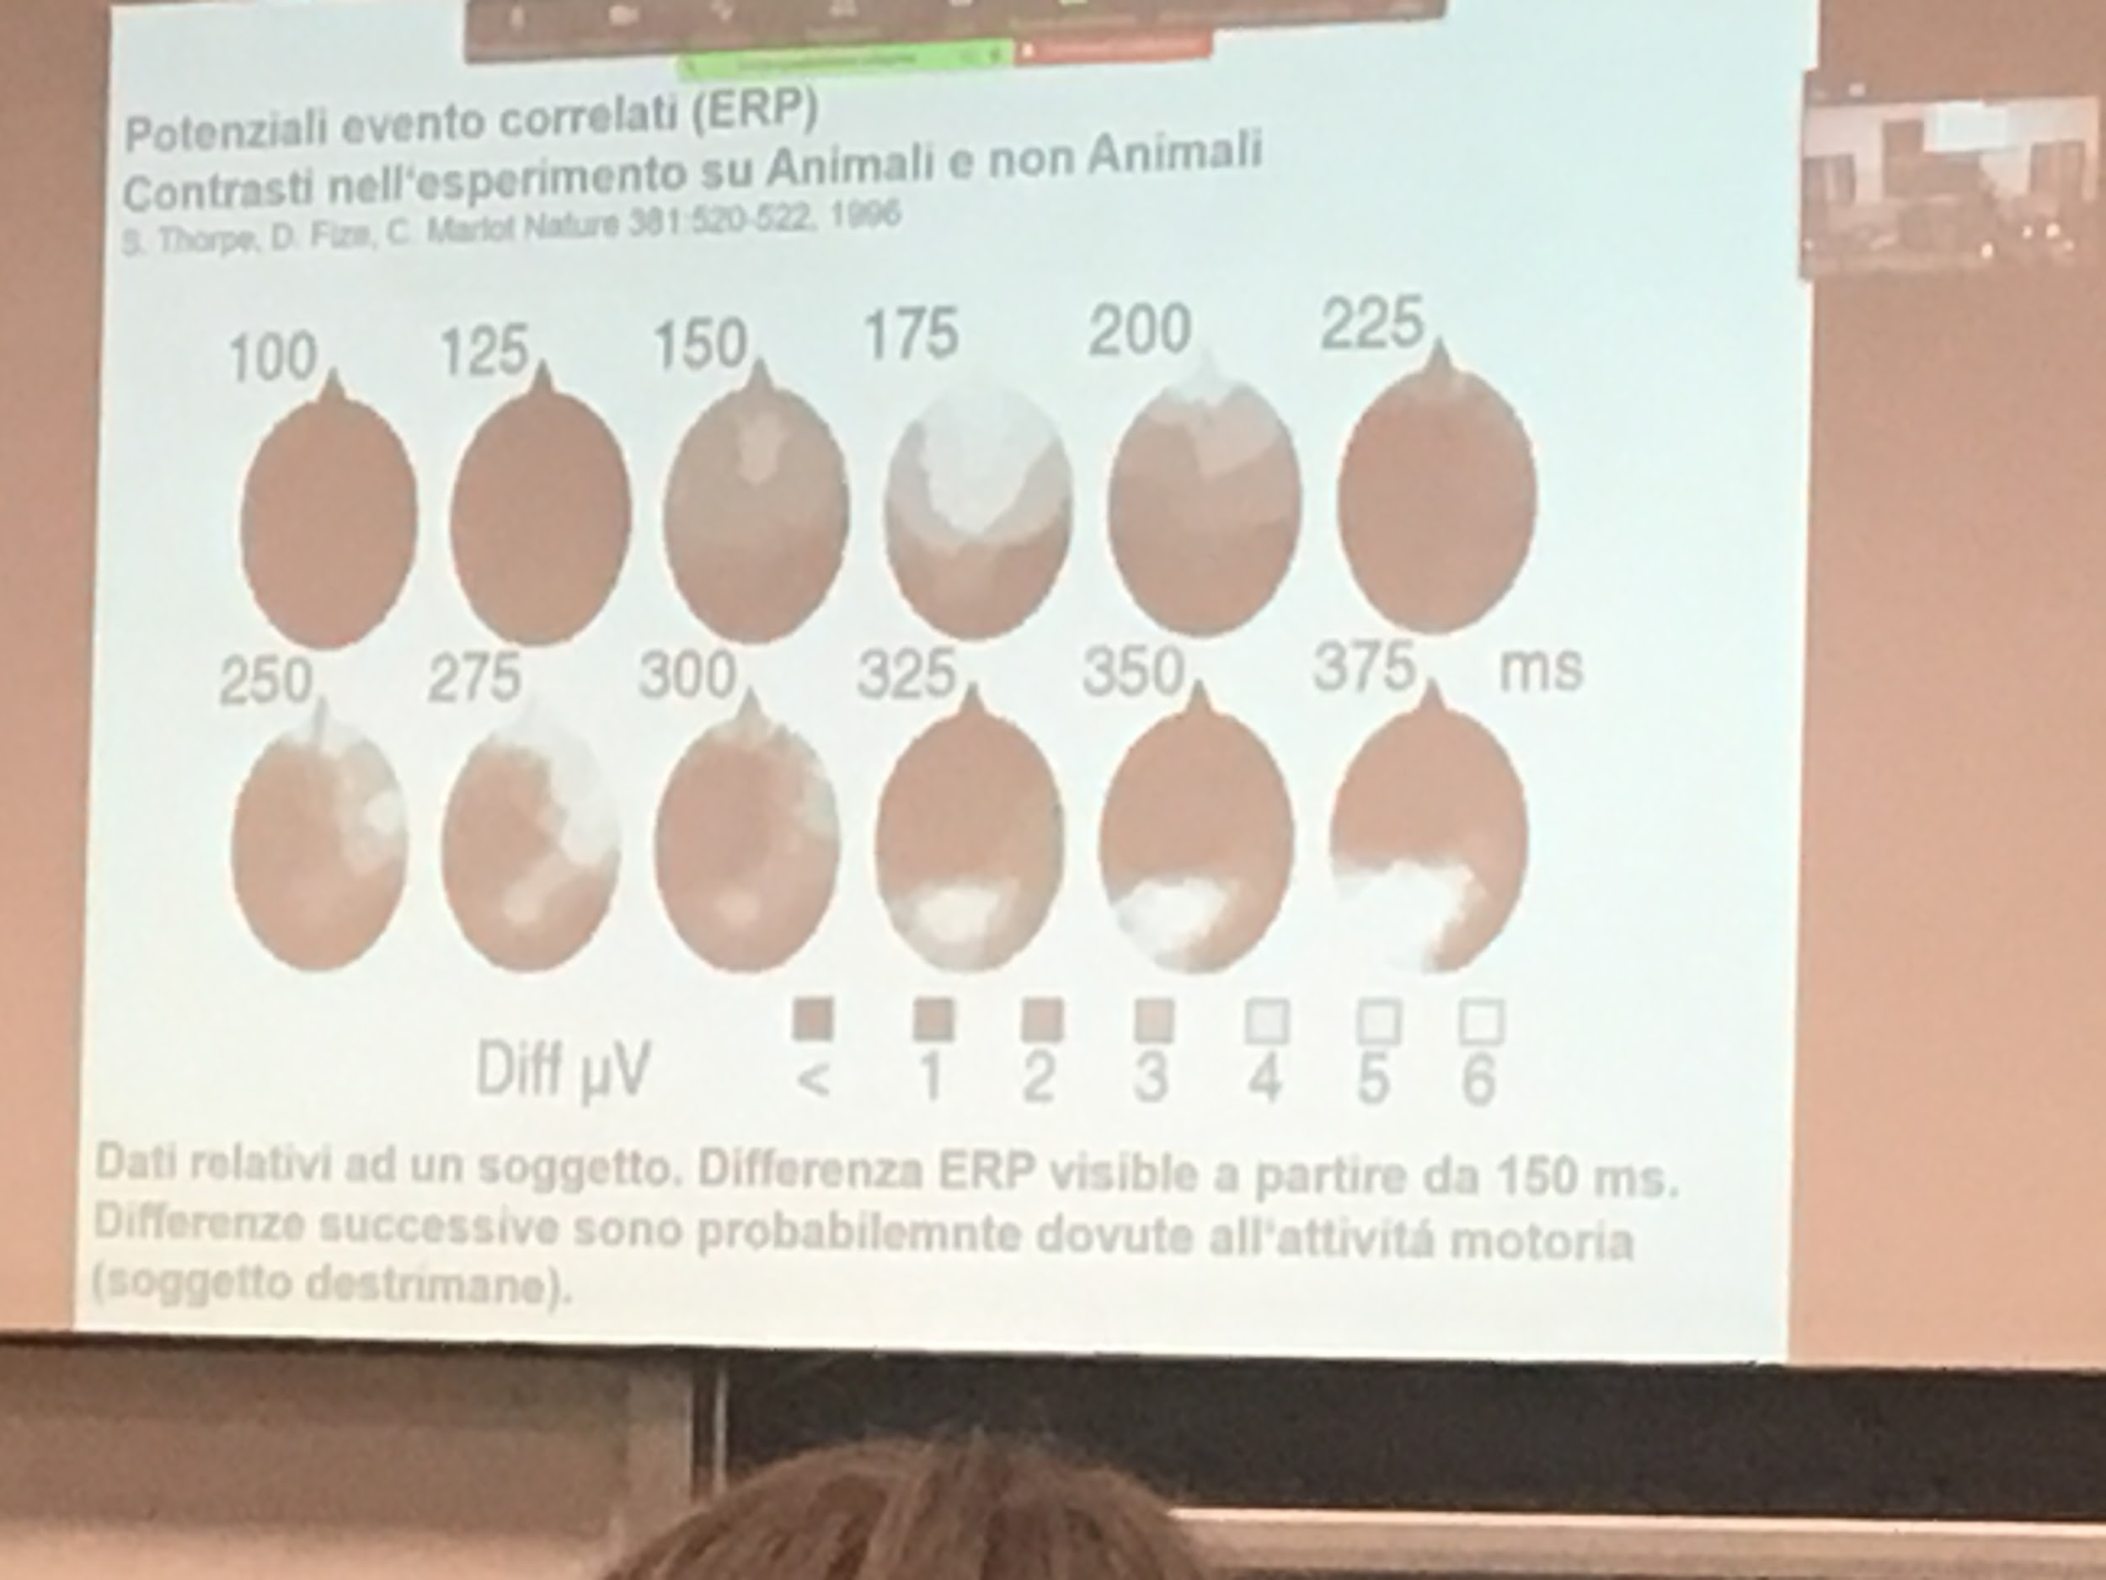

Conte eg on the scalp, register activity

The idea of where we are (gist) is very fast (20 ms) to do the gist of the scene, for the dentils it takes longer

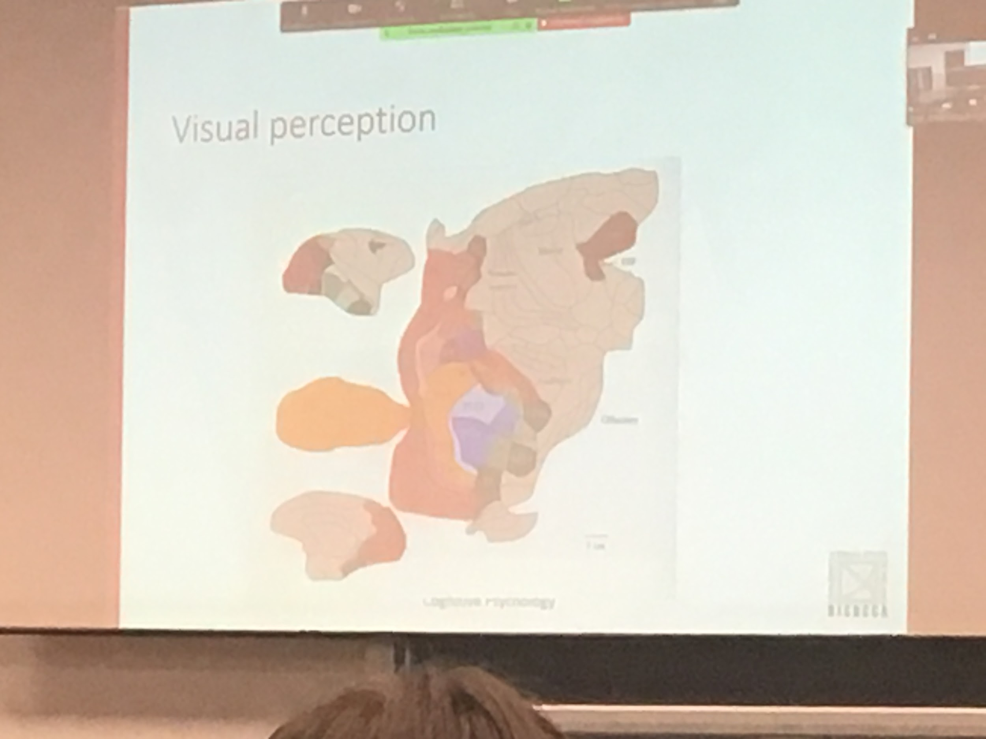

Later view of the monkey brain. Color represents part of the brain used for view perception.

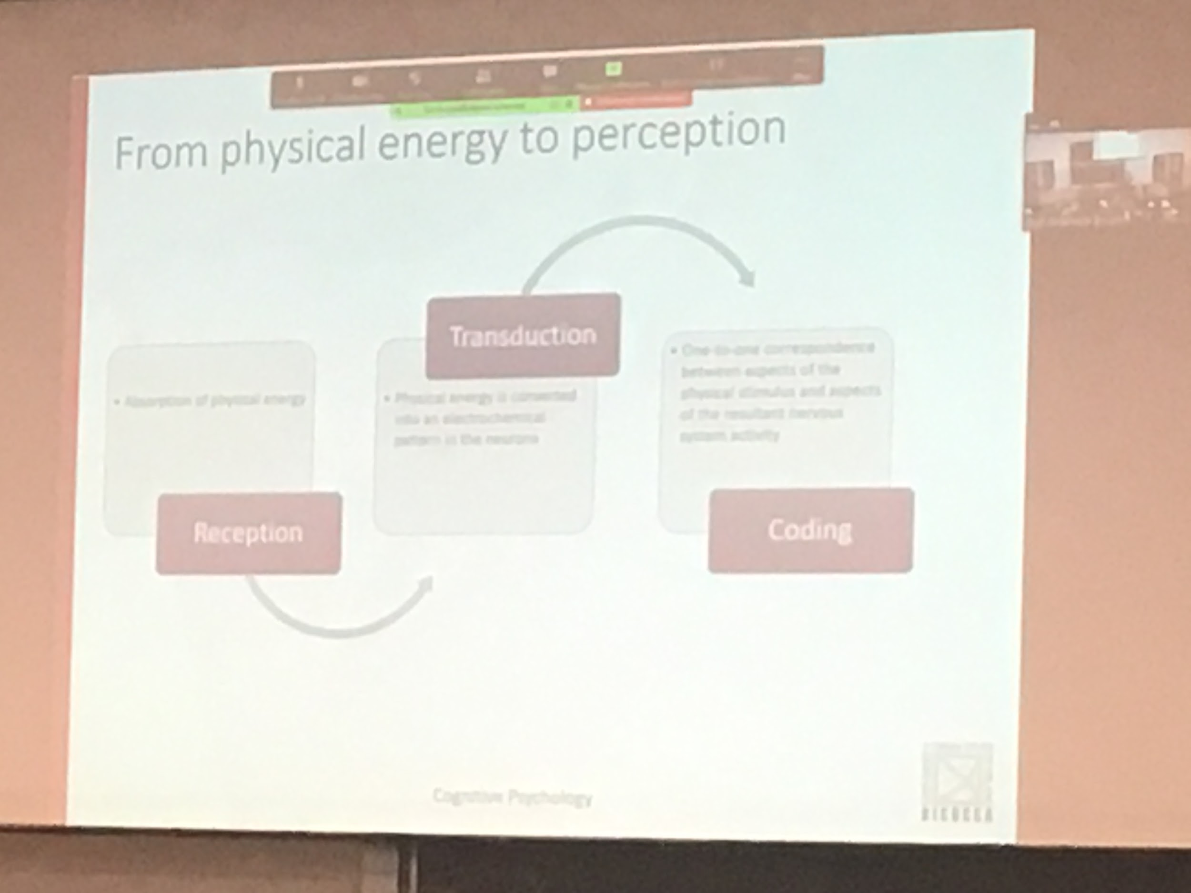

We start from physical energy (light, electromagnetic energy)

Touching some specific cell in the eye (receptors) they perform transduction, transforming physician energy in neural activity. In the retina there are the photoreceptors, each step of neutrons performing a different type of computation. Processing in different modes.

The information is transducer. Different levels are done creating new representation at each level.

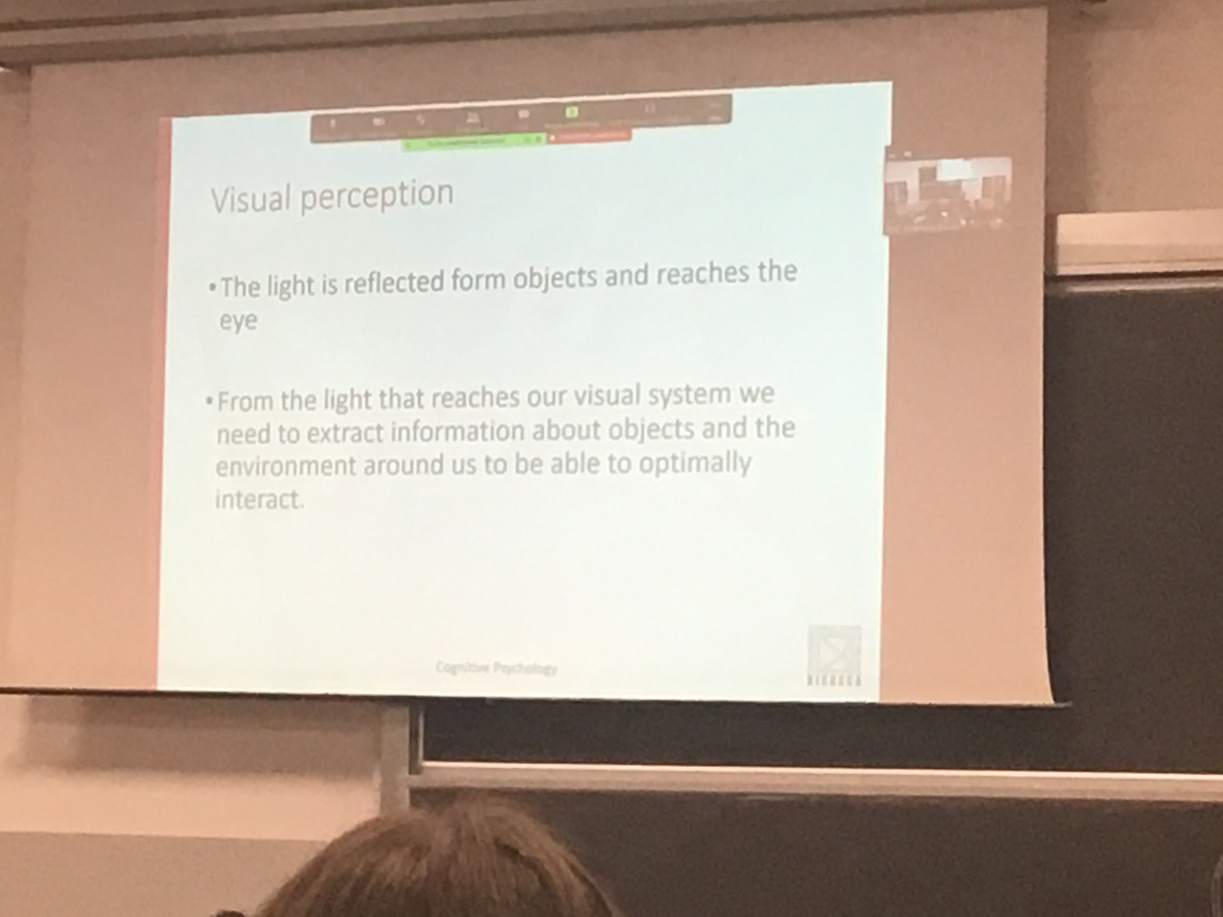

Light travels straight, heads objects and is reflected in interesting ways. Preserving some types of informations

We are interested in the object, not about the light.

Having a different light source gives a different path. What vision system is done it needs to see in the same way. Depending on the colour of the light.

Different light sources create different paths of reflection from the same object. The great ability of the visual system is to maintain a constant to perceive the same colour even if the path of the light is different. But the perception is the same

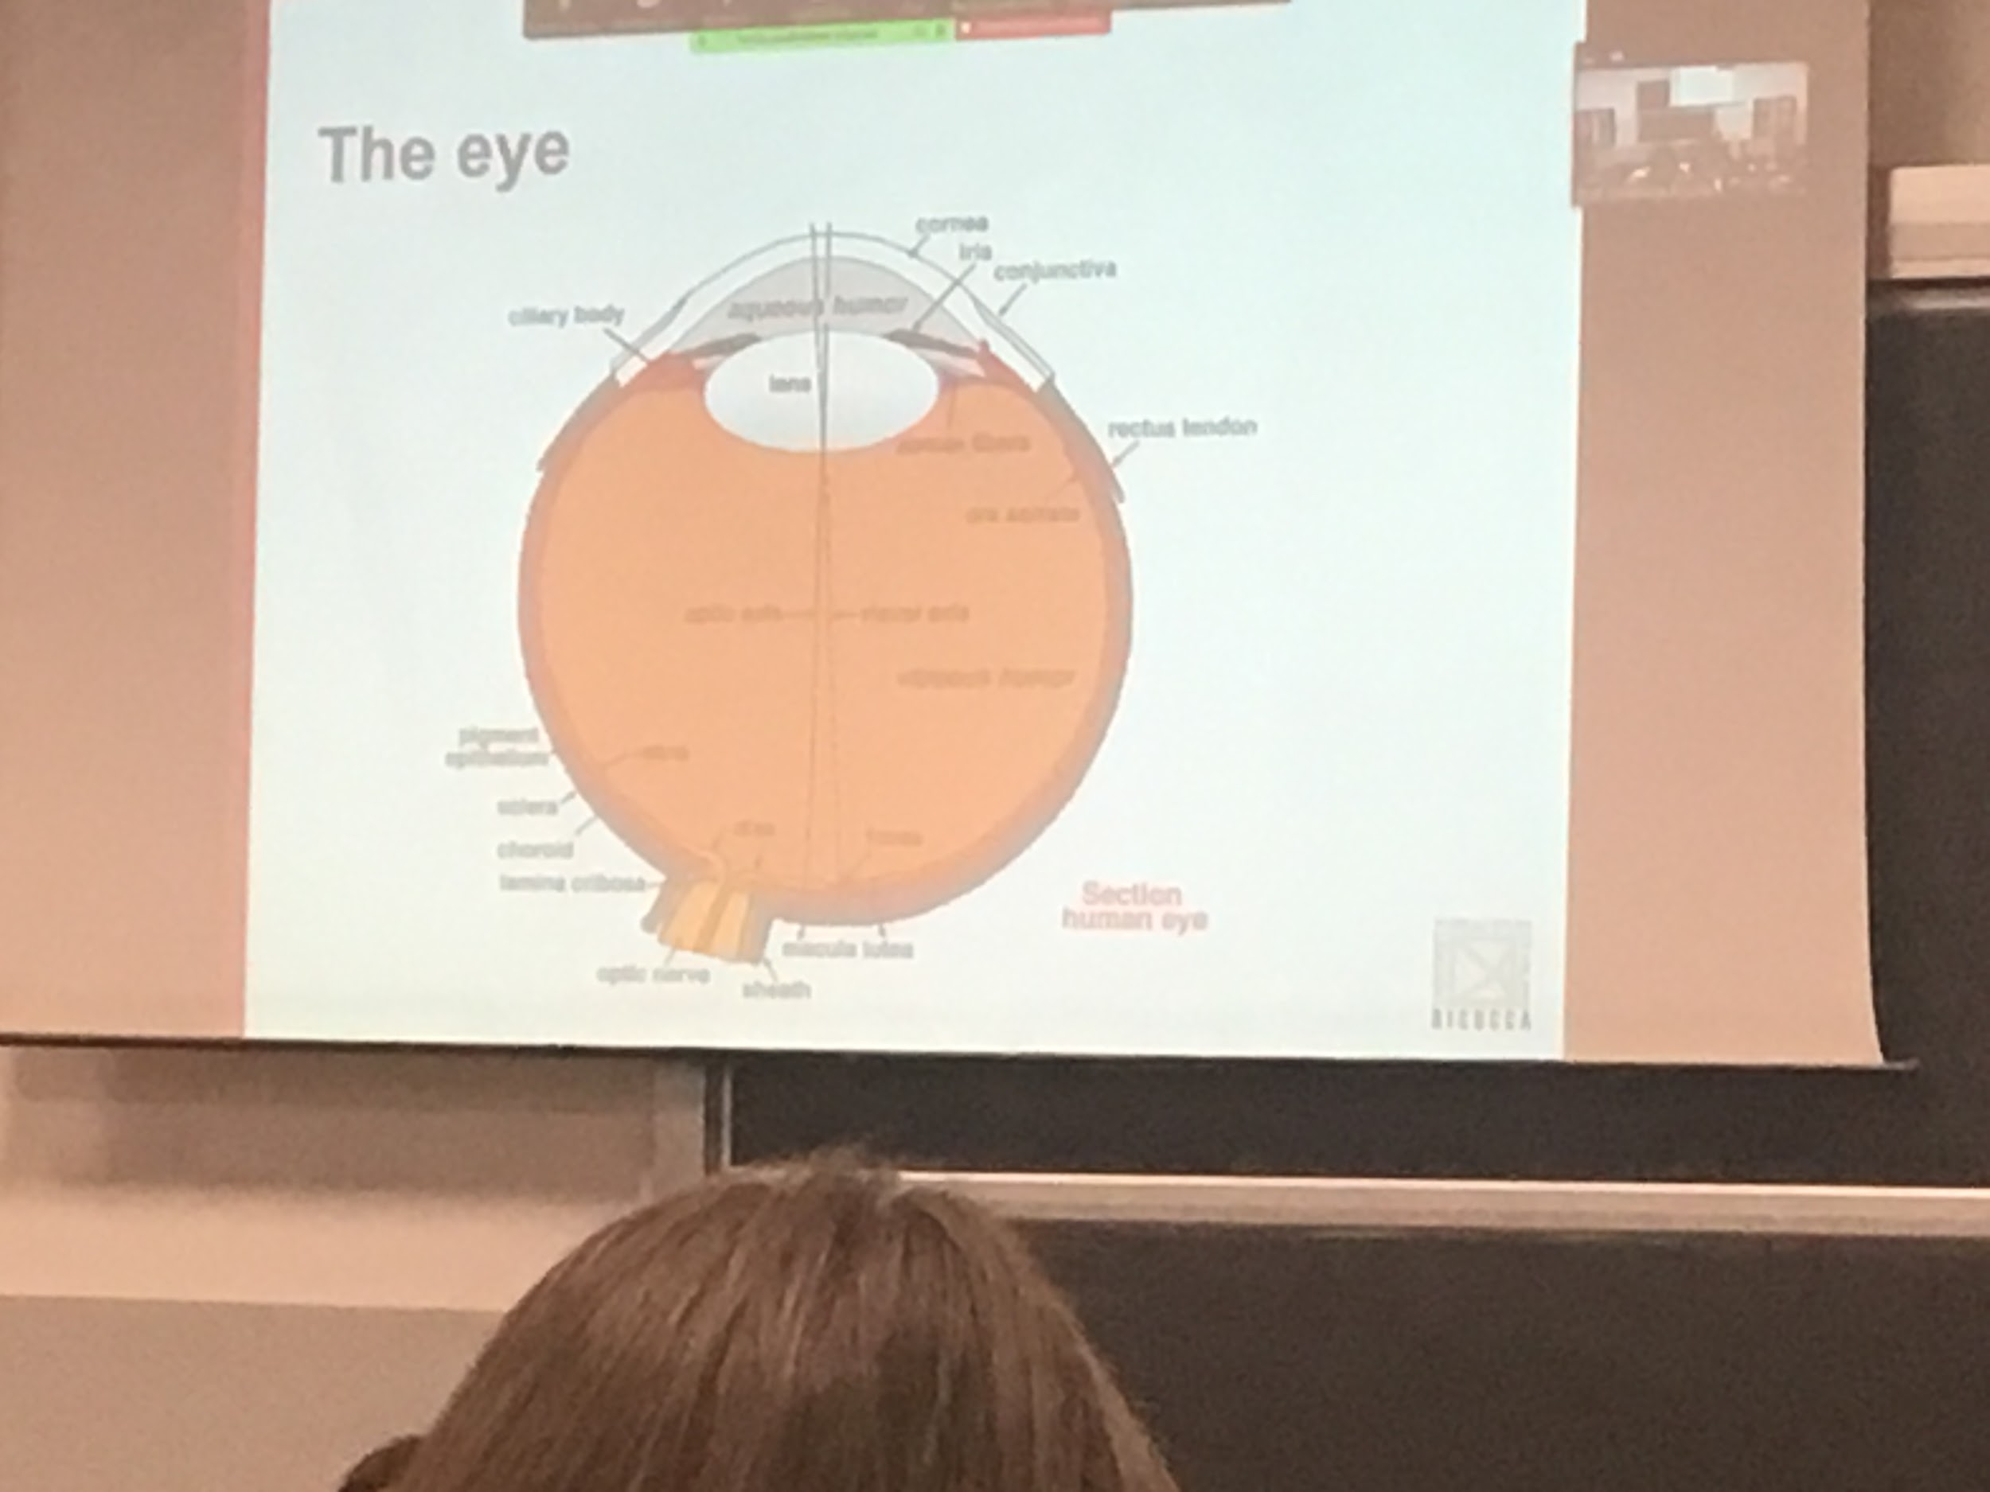

The eye works like a camera.

The lights heat the inside layer. In the retina there are 3 types of cells. One of them is the photoreceptors. Photoreceptors when heat transform the information in neural application

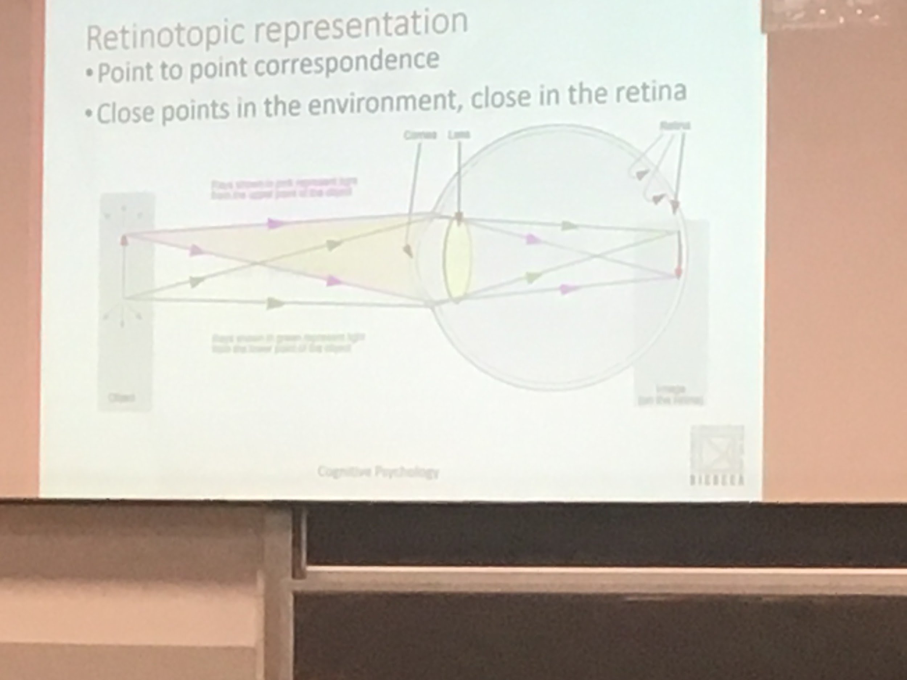

We need to understand not only what but also where it is. We need to know where the objects are. We have to maintain spatial information.

Points that are close to use attiviate points close by in the retina.

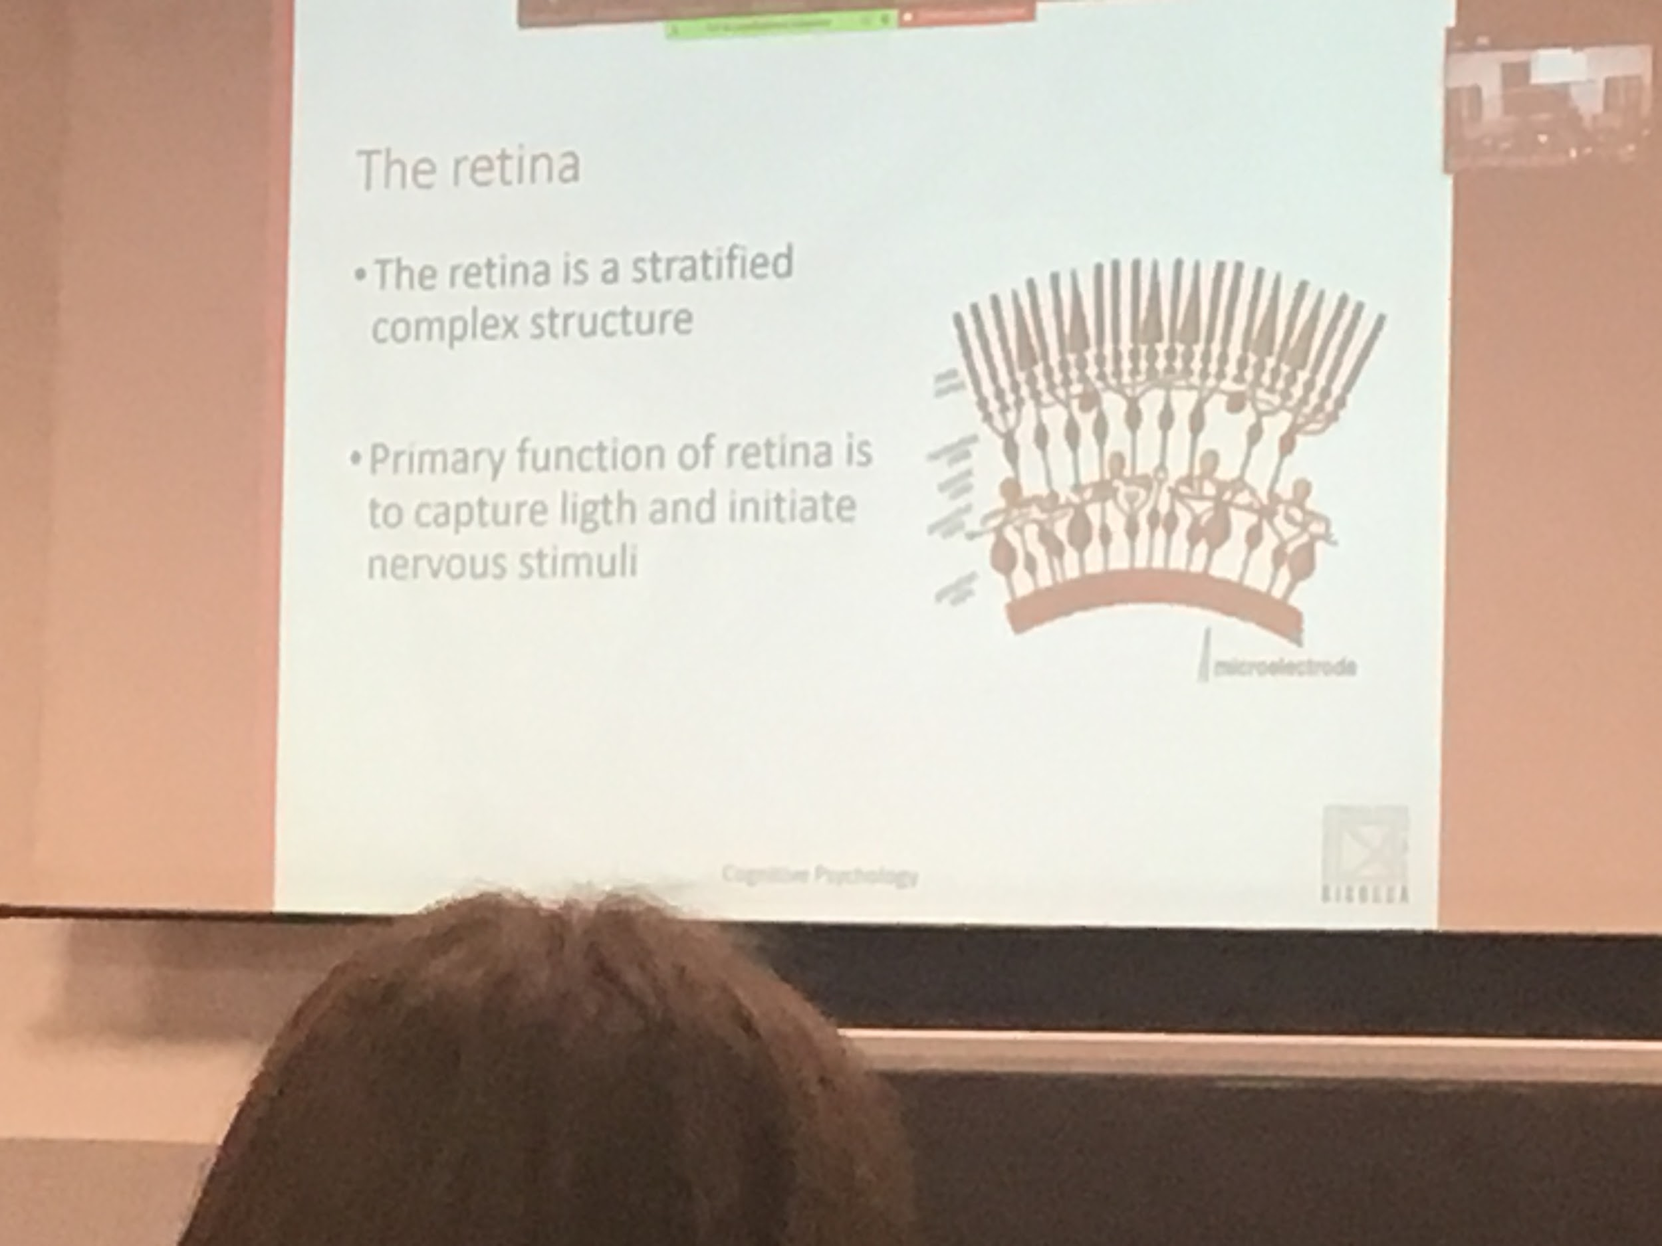

The computation is alarmed by what is done in the retina, what comes out of the retina is not just information.

There are two types of visual receptor cells in the retina: cones and rods

Cones are used for colour vision and sharpness of vision

Rods: specialised for vision in dim light(barlume)

Cones: three types of cones respond differently to different wavelengths. Allows us to code colors. Without codes or with codes multifunction (daltonics) do not distinguish the specific wavelengths

Rods and cones: very small receptive field. Rods are more sensible to light. Even one photon can activate a rodes but much more are needed to activate cones

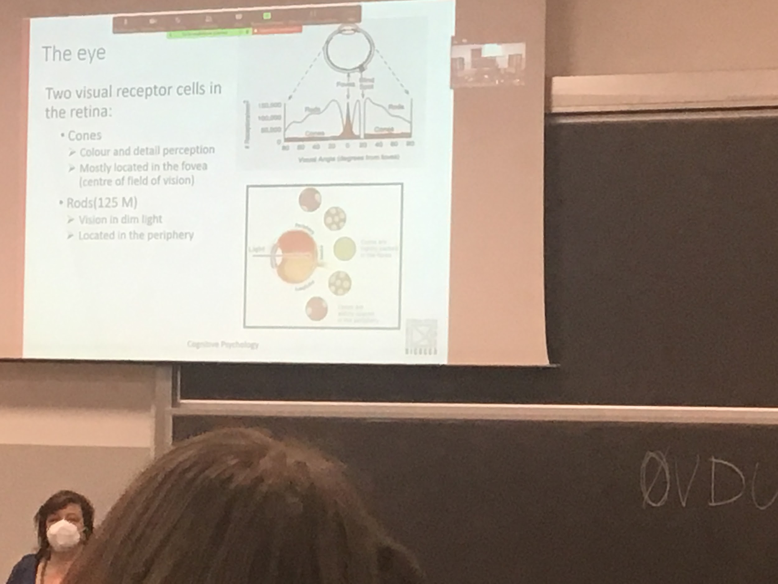

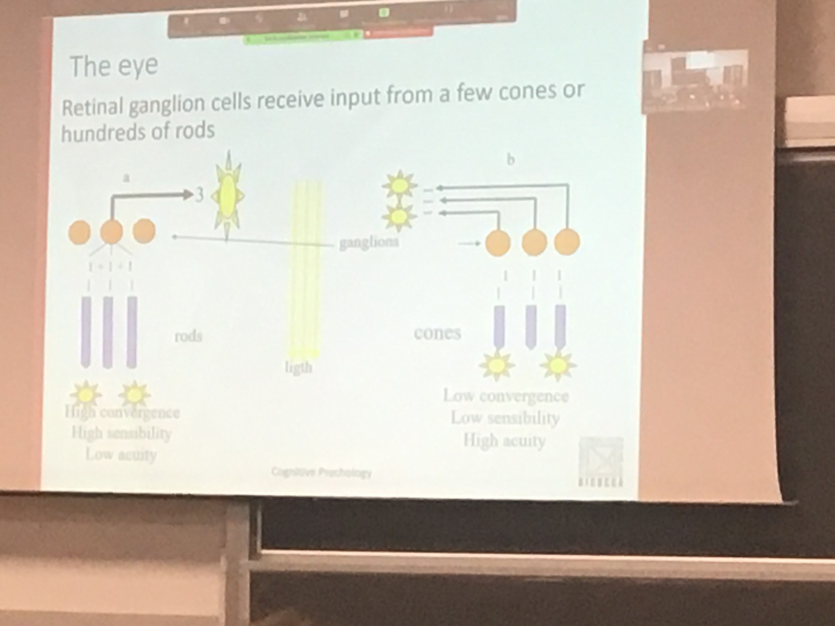

The difference between cones and rods is that they have a receipt filed. But rods are more sensitive to lights.

Information from different rods converges. Information is not marinated separately. Informations is converged

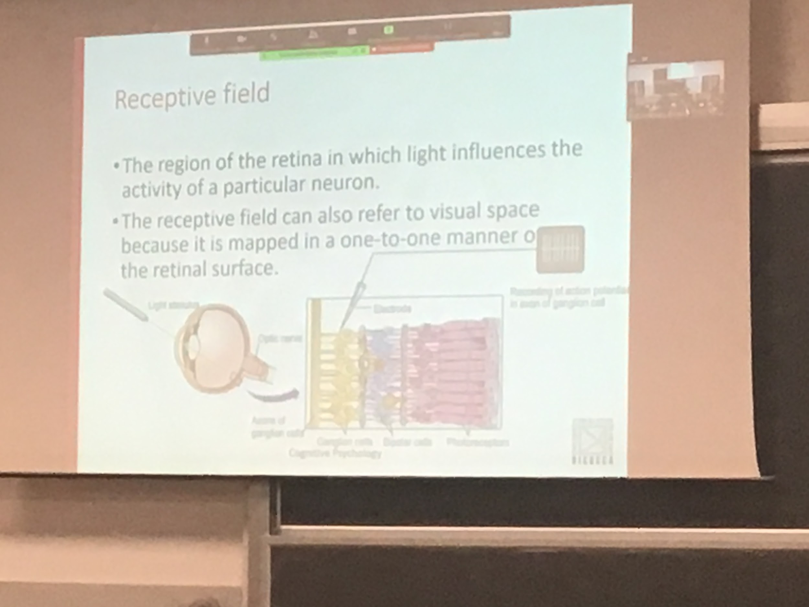

Contains light to have my code activated. Can have light everywhere. If the light is not coming from a specific point the code will not respond.

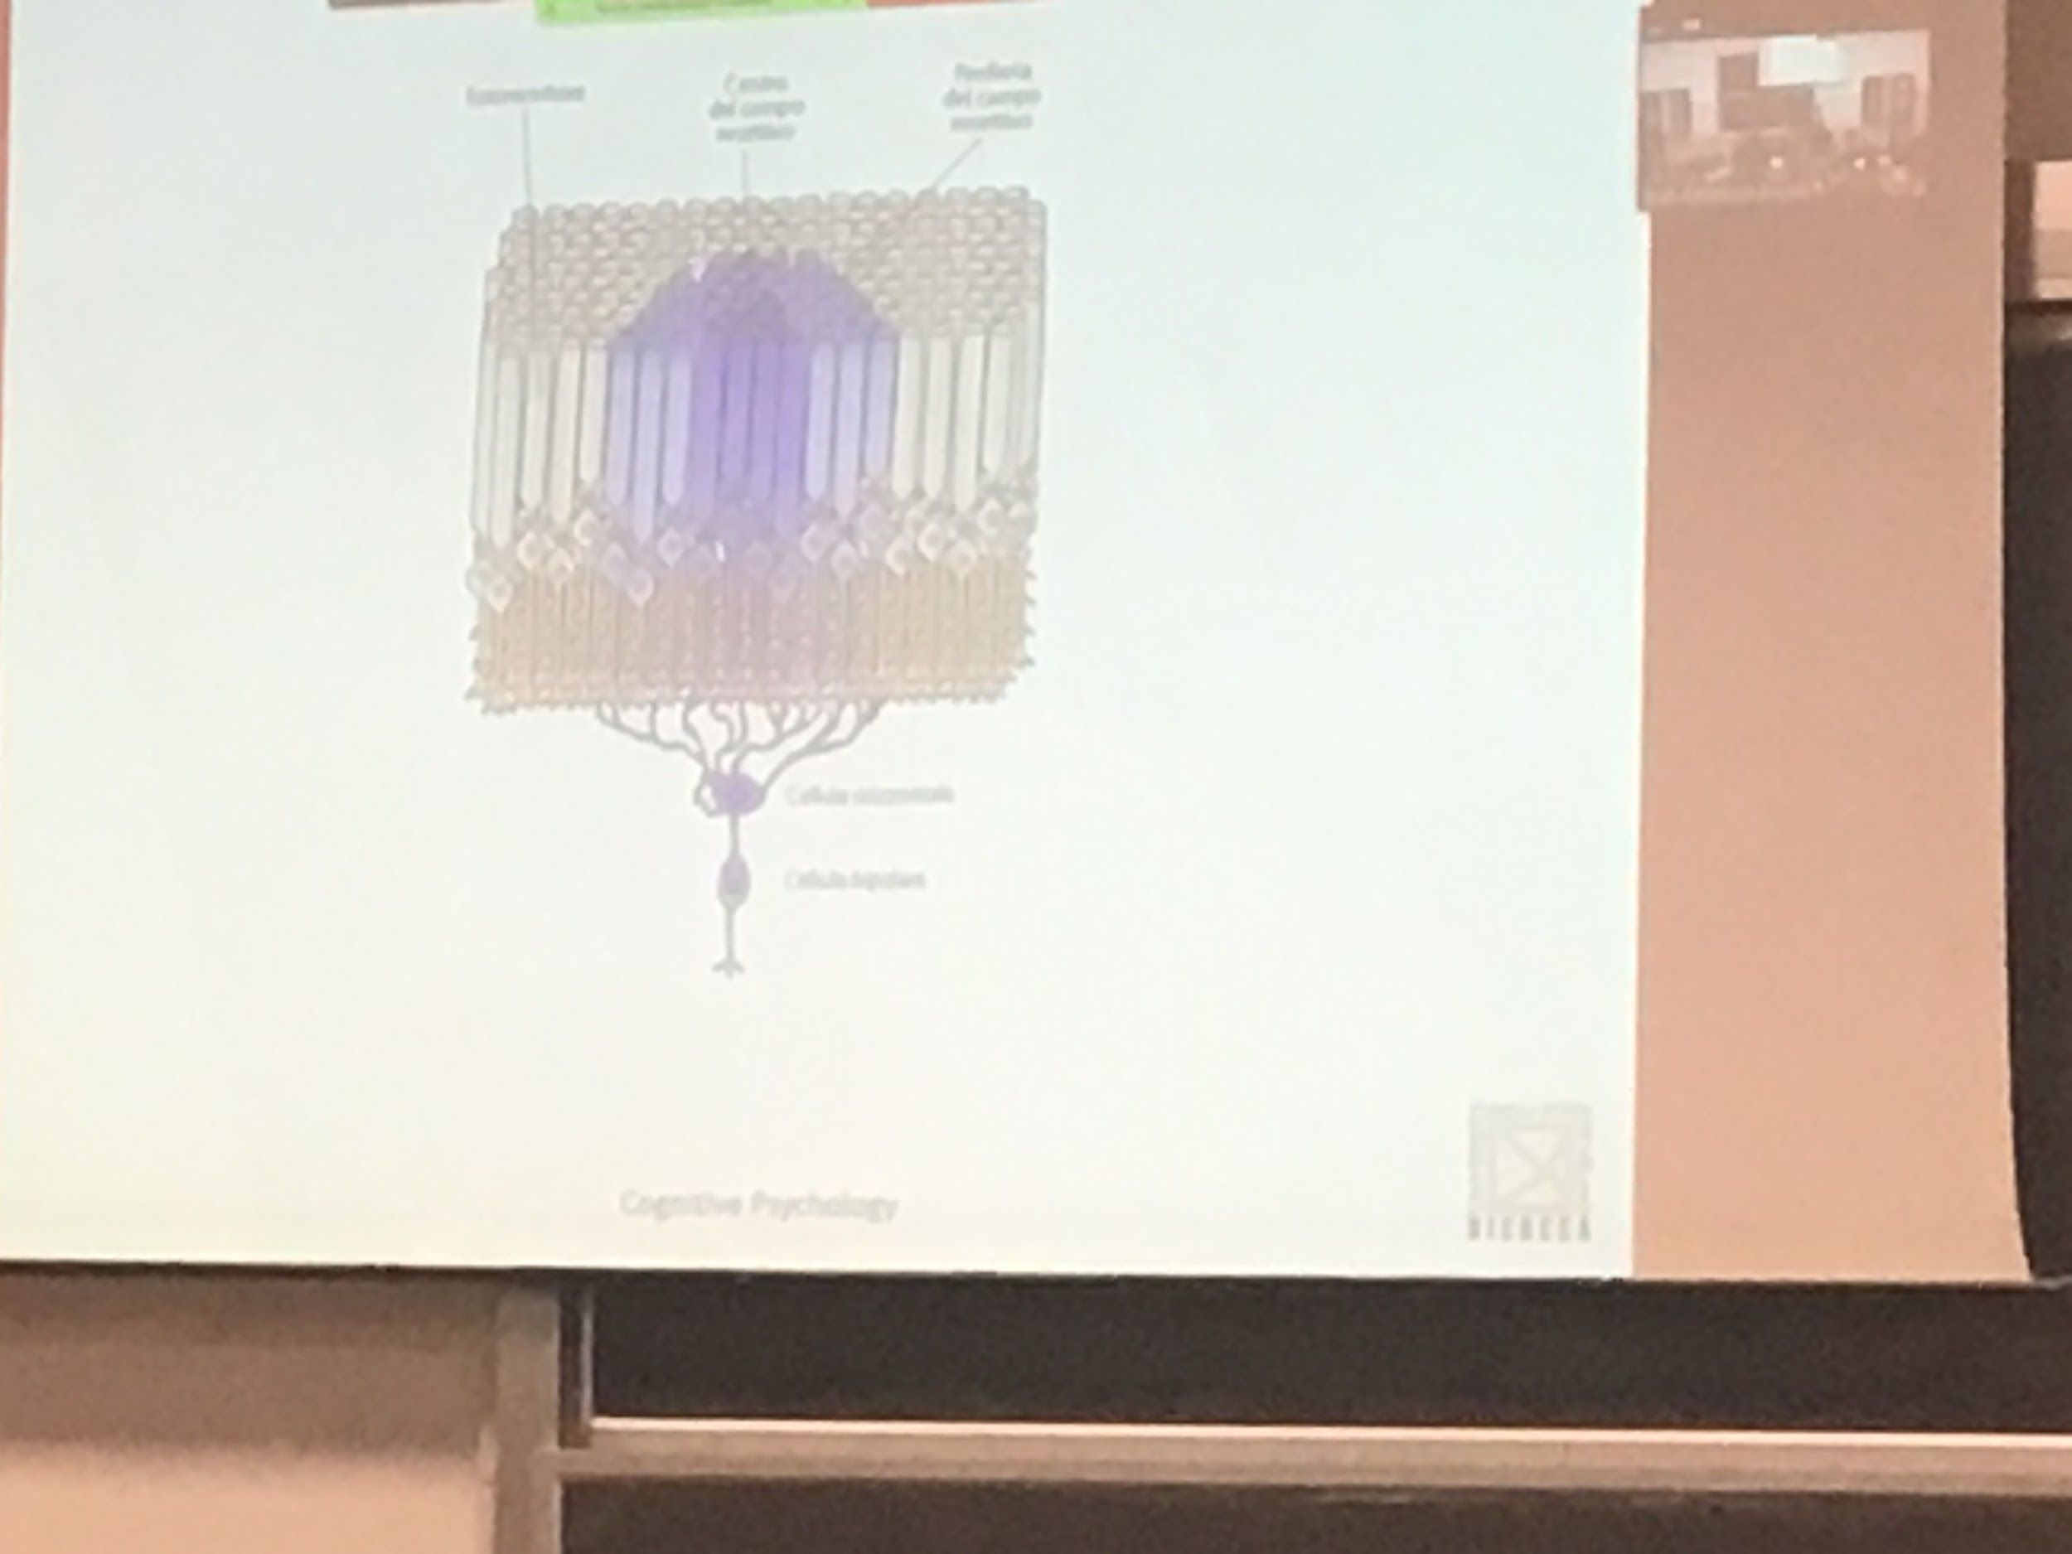

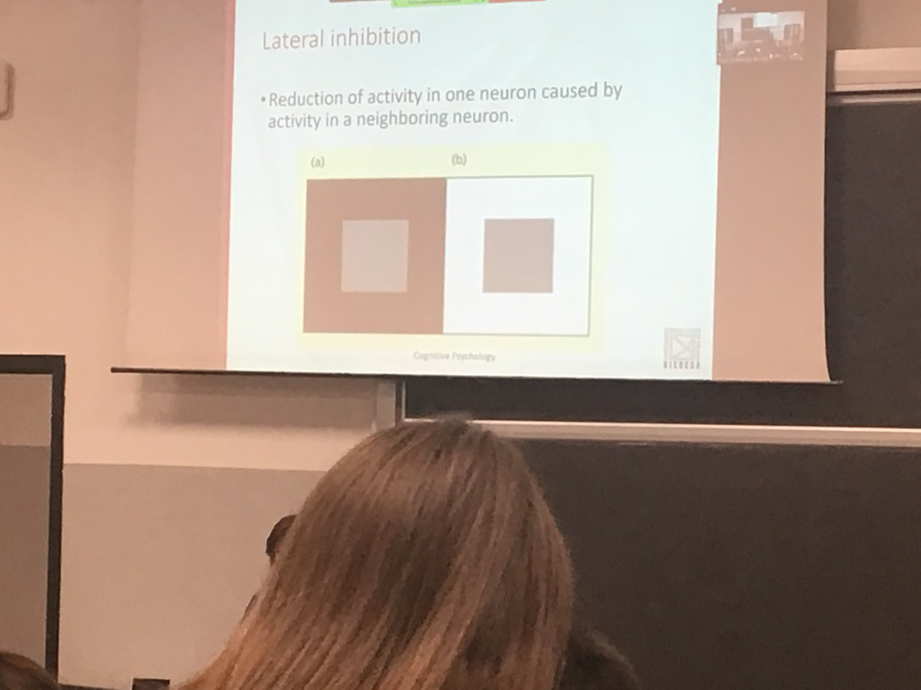

A ganglion that has a border is more active, the two grays are identical. If you record the amount of light from the gravy it is the same. If there is uniform activity the ganglion is not very much active

Lateral inhibition: increase the difference from the border. Tray to increase the difference in the border to better understand the object

Lateral inhibition: reduction of activity in one neuron caused by activity in a neighbouring neuron

Neurons often influence each other. Lateral inhibition increases the contrast at the edges of objects making it easier to identify the dividing line between objects

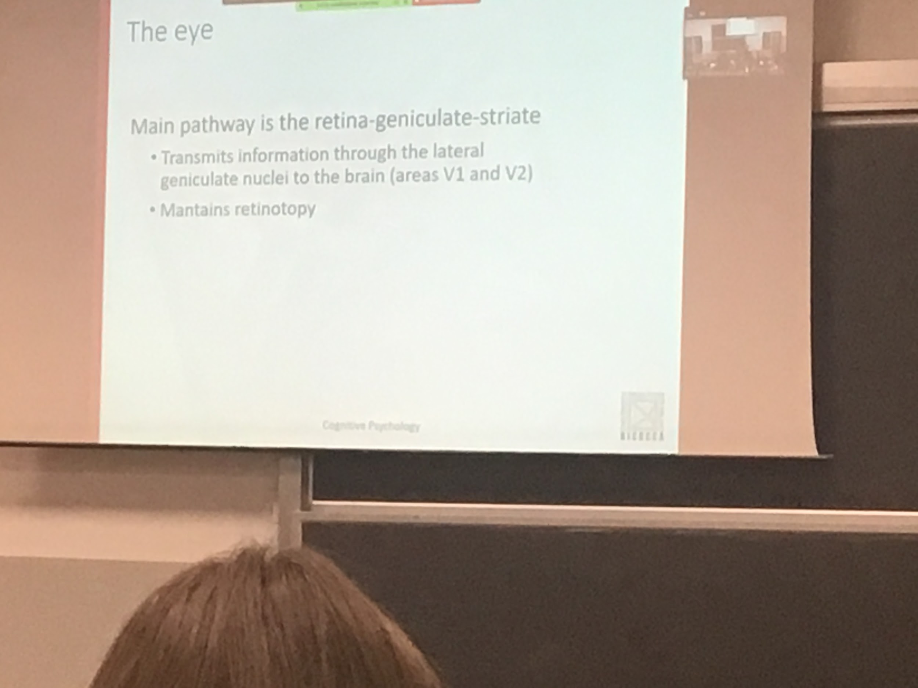

Lateral geniculate nuclei. This information is transmitted and maintains retinopathy. The informations is maintained separated for different types of gagnolar set

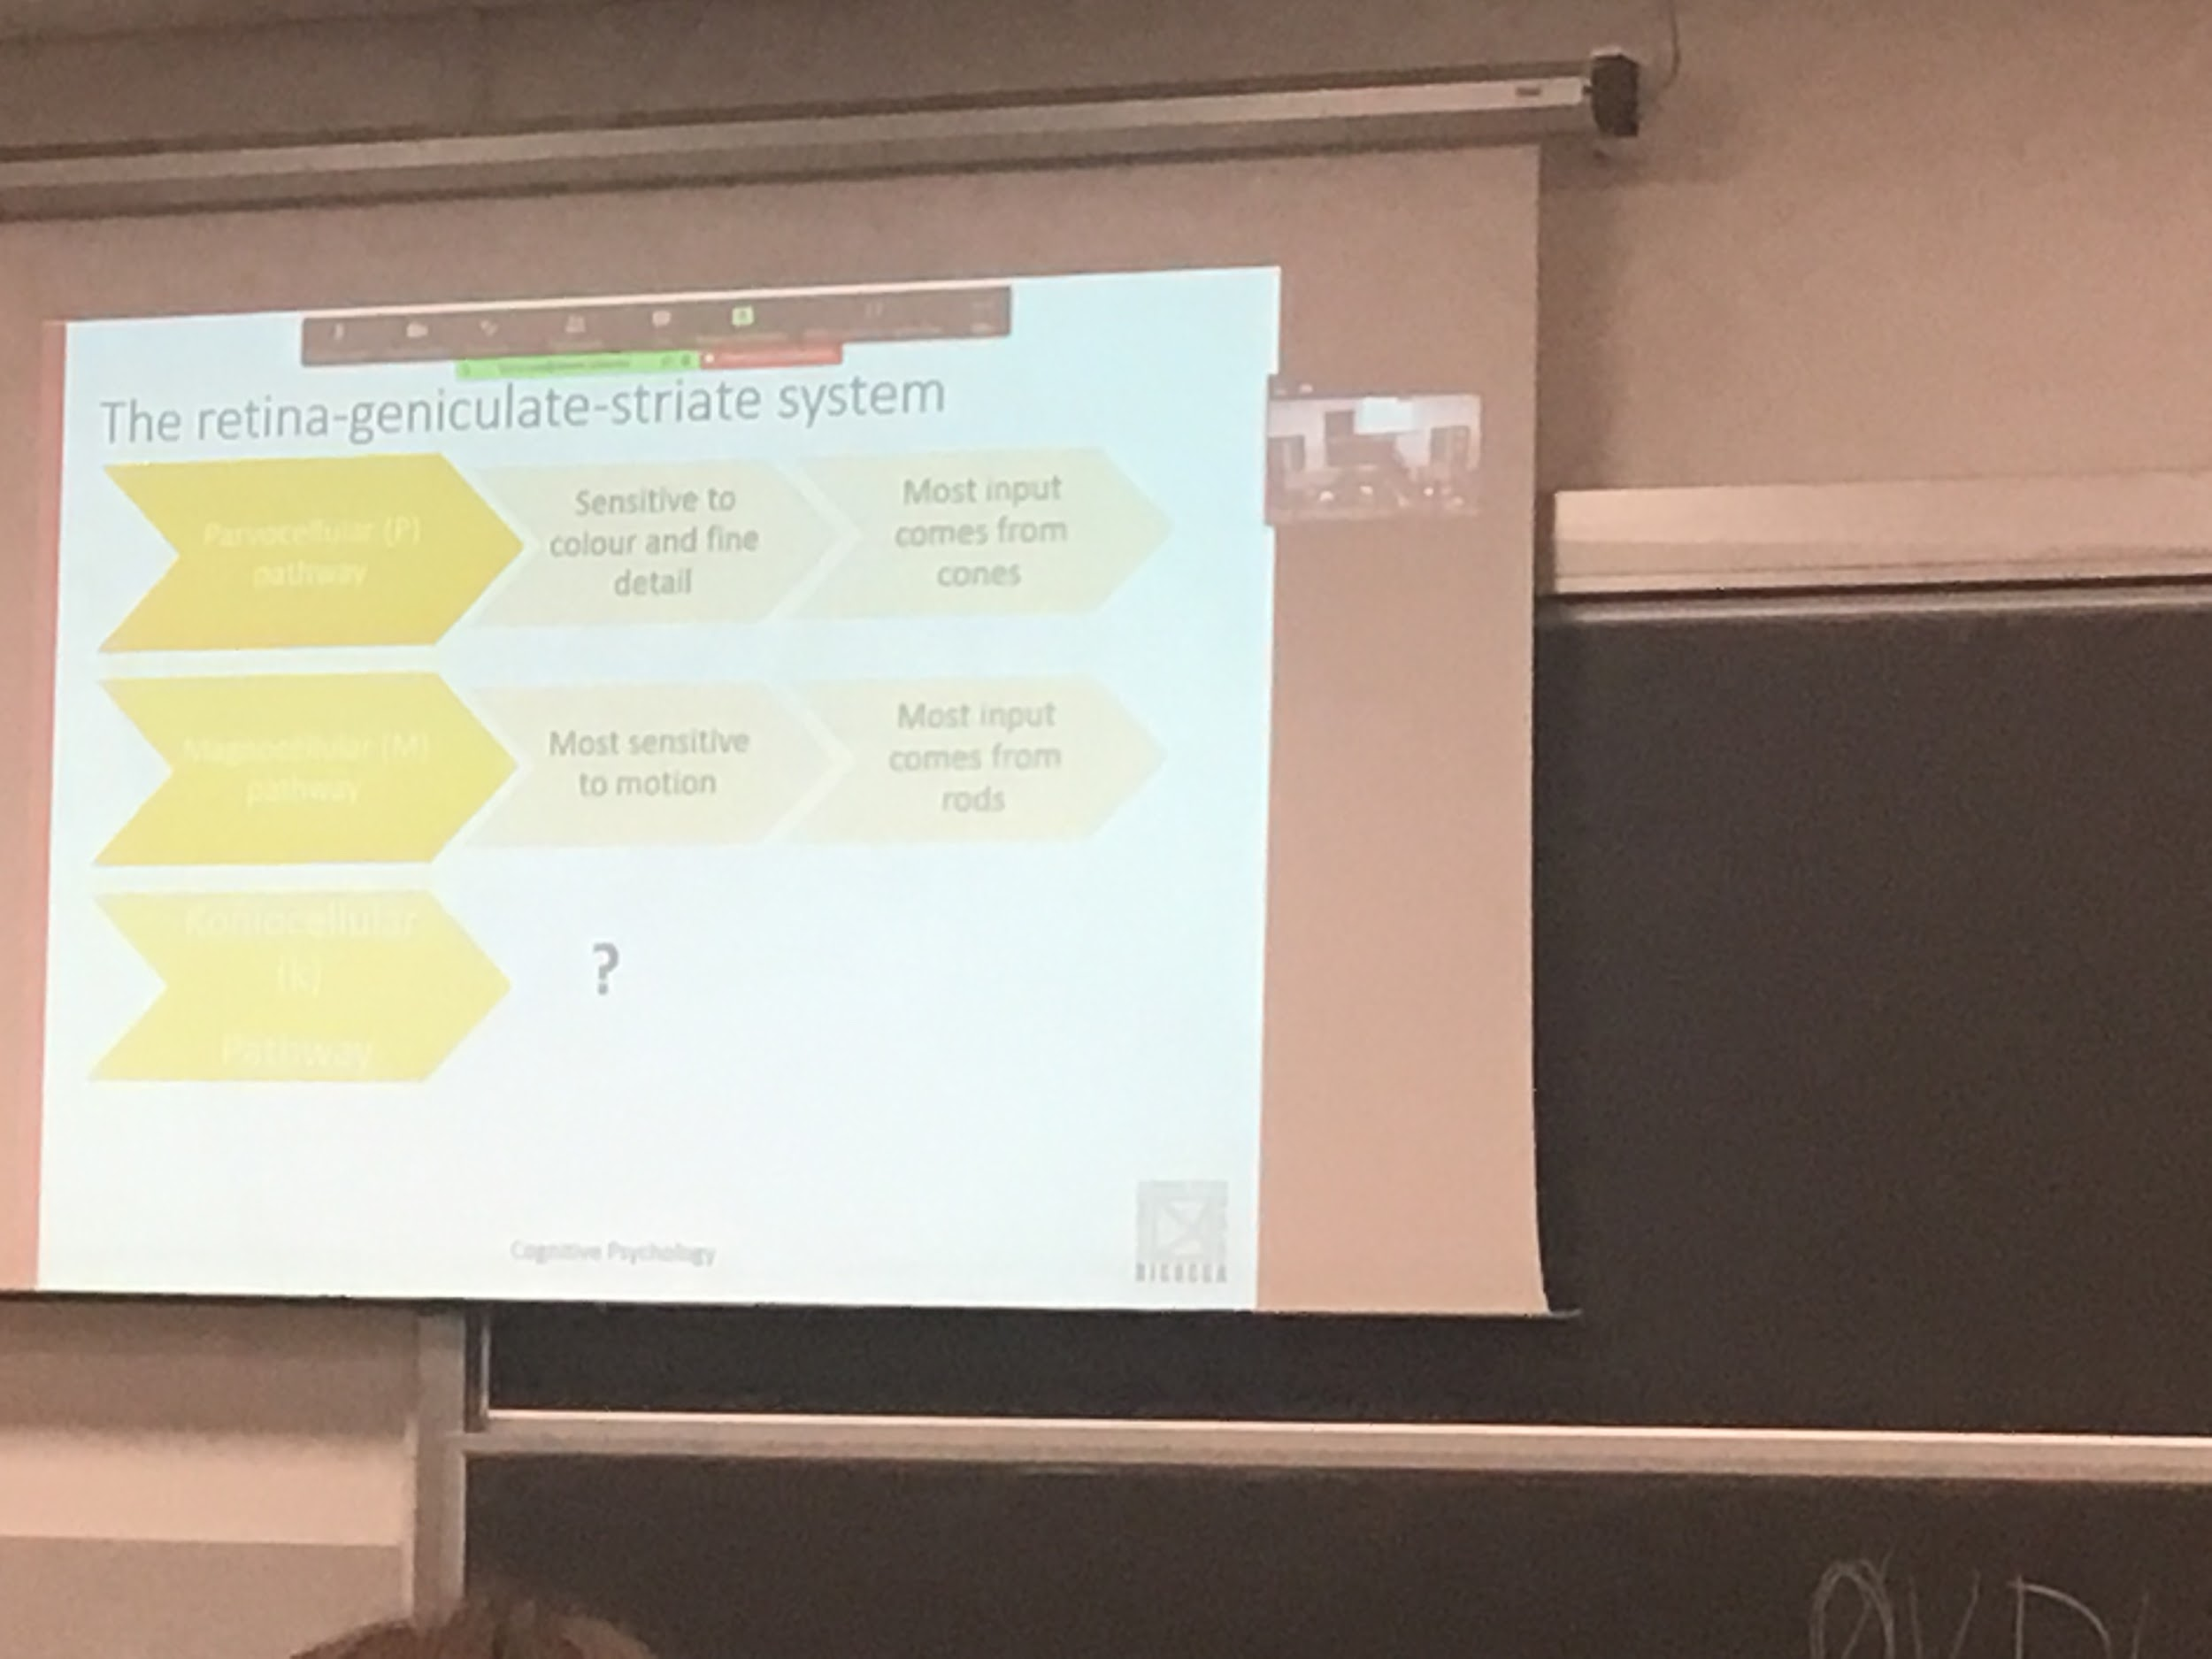

Some neurons are more sensible to colors while some are better to understand motion

The information is maintained separately to help us discriminate right at the beginning. 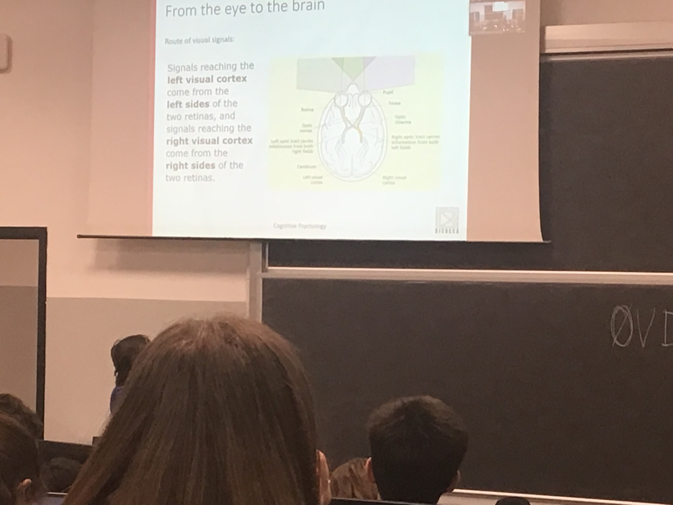

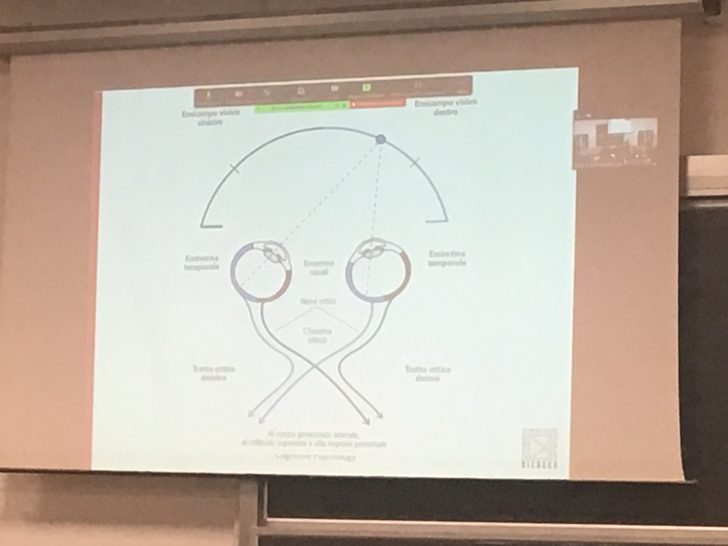

We have two eyes with two different representations of the word, but we only have one. We have to put the informations of the two eye together

Half stay on the same side Half cross to the other side

What is view on the left is processed on toe tight

Each eye has its own optic nerve and the two optic nerves meet at the optic chiasm.

Each side of visual space is represented within the opposite brain hemisphere.

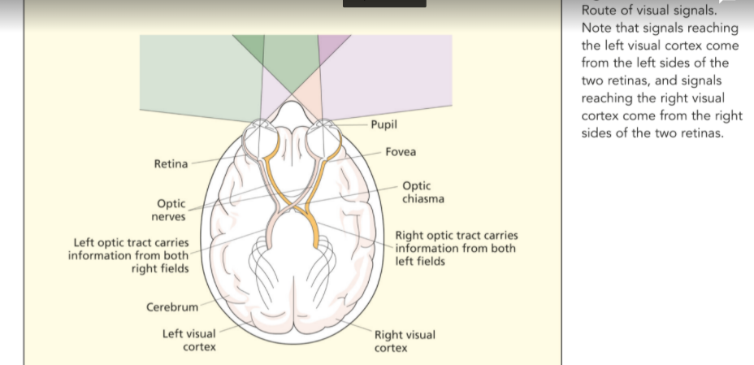

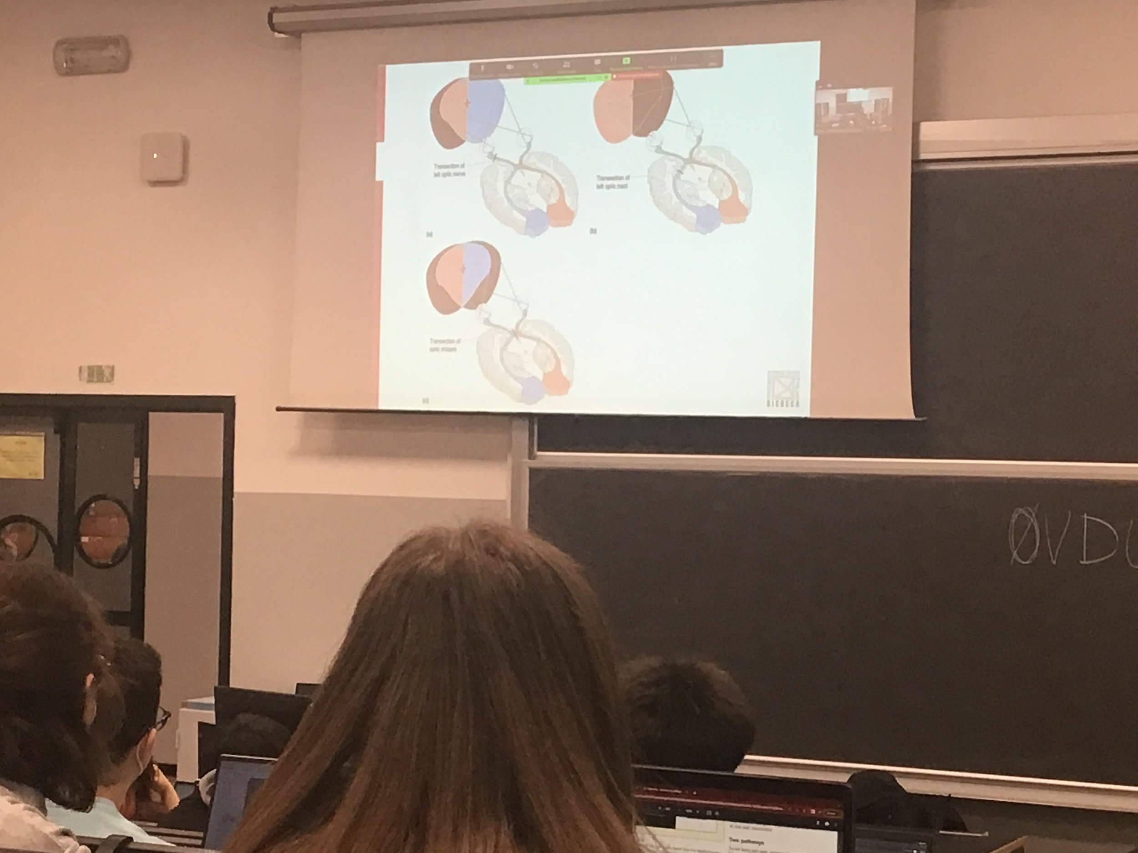

Different kind of lesion

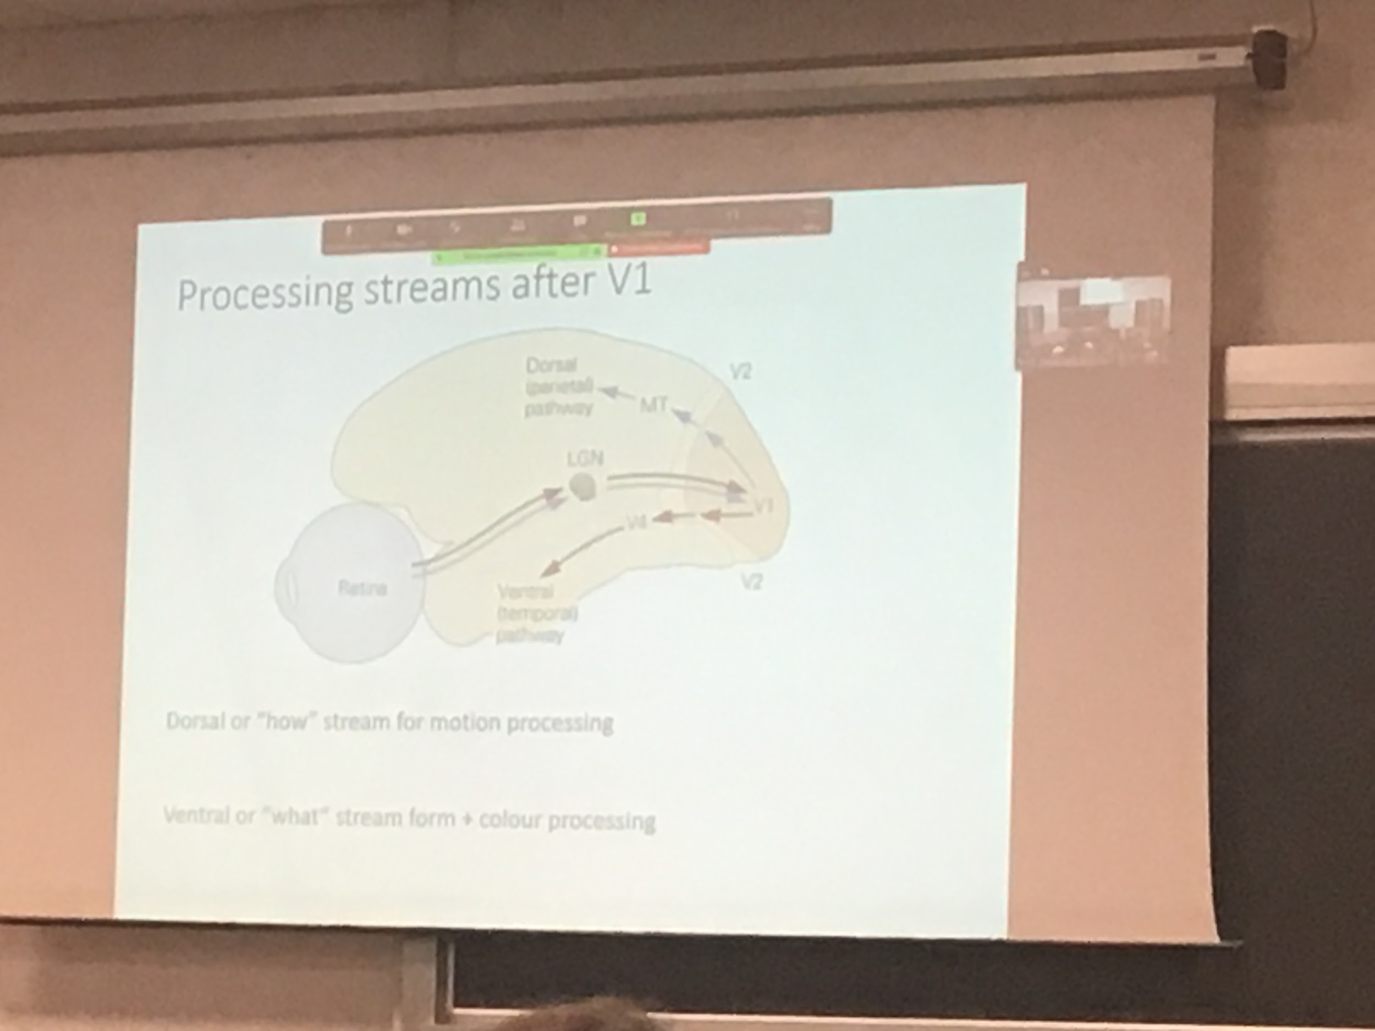

LGN module of the brain, the old part of the brain, axions from the retina not go straight to the cortex because they get rearrange.

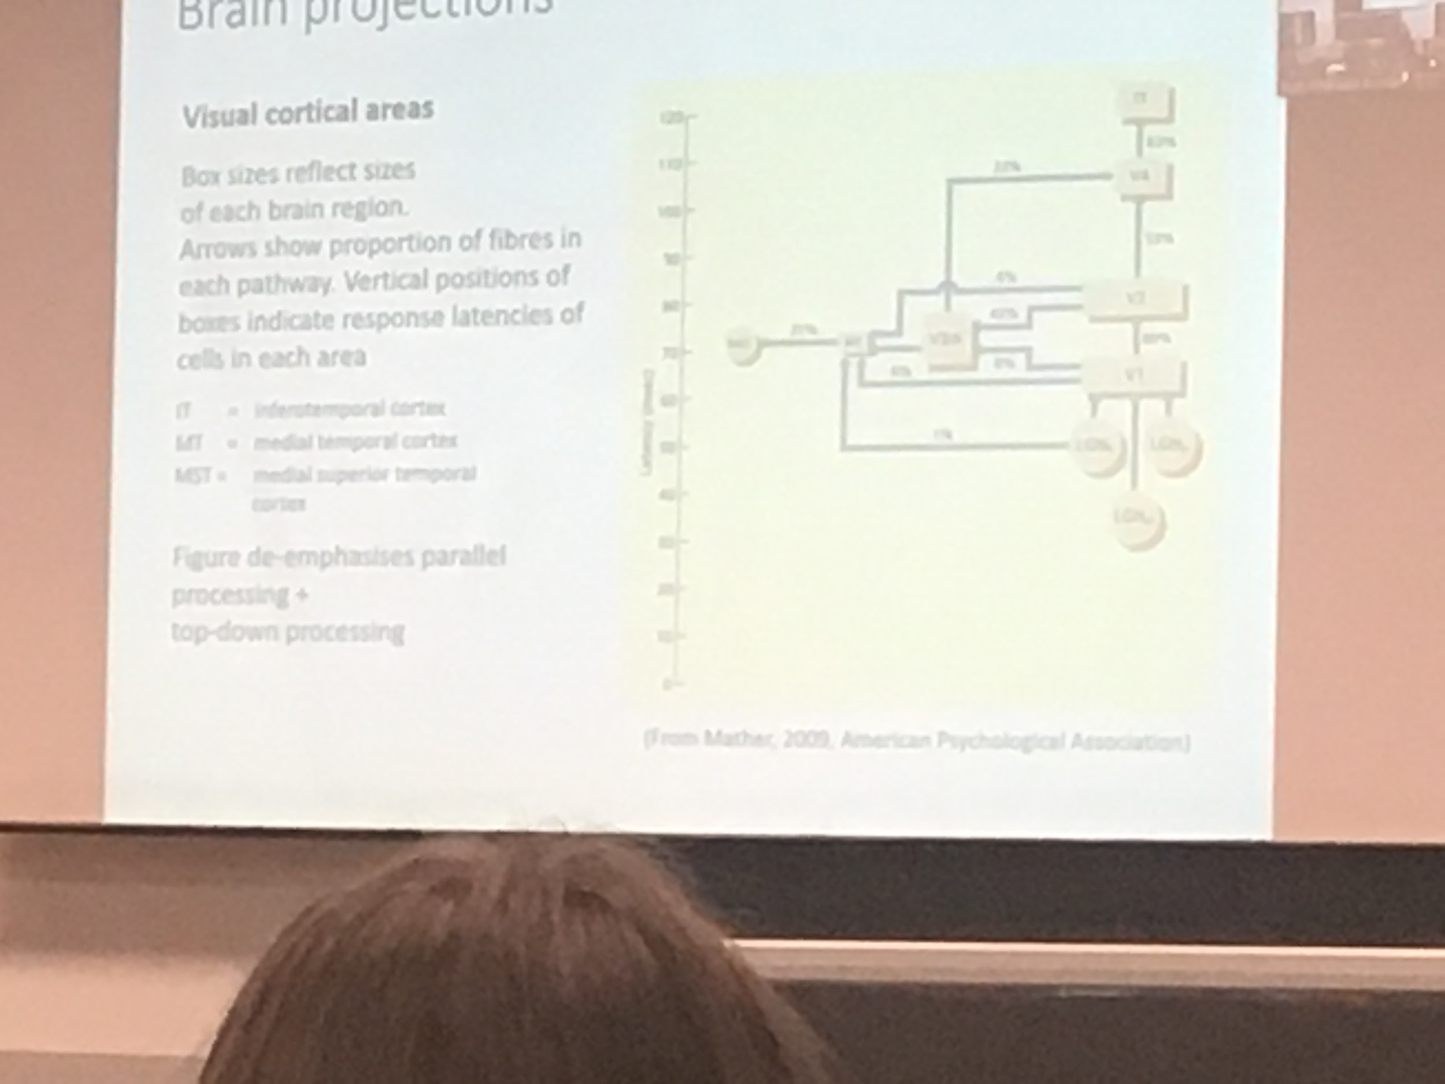

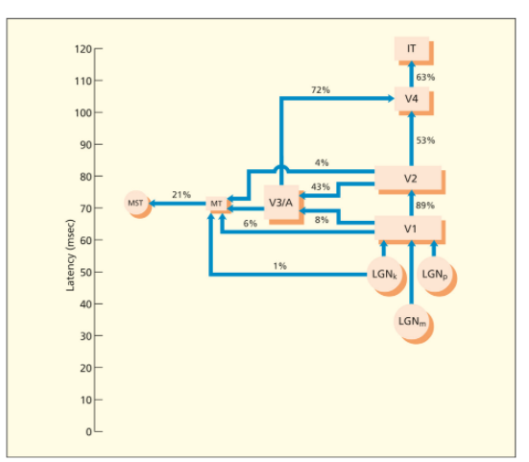

There are some complex interconnections among visual cortical areas.

The brain areas within the ventral pathway are more than twice as large as those within the dorsal pathway

Cells in the lateral geniculate nucleus respond faster when a visual stimulus is presented followed by activation of cells in V1

Brain projections.

On y-axis time when it is activated.

The % represent how much informations goes

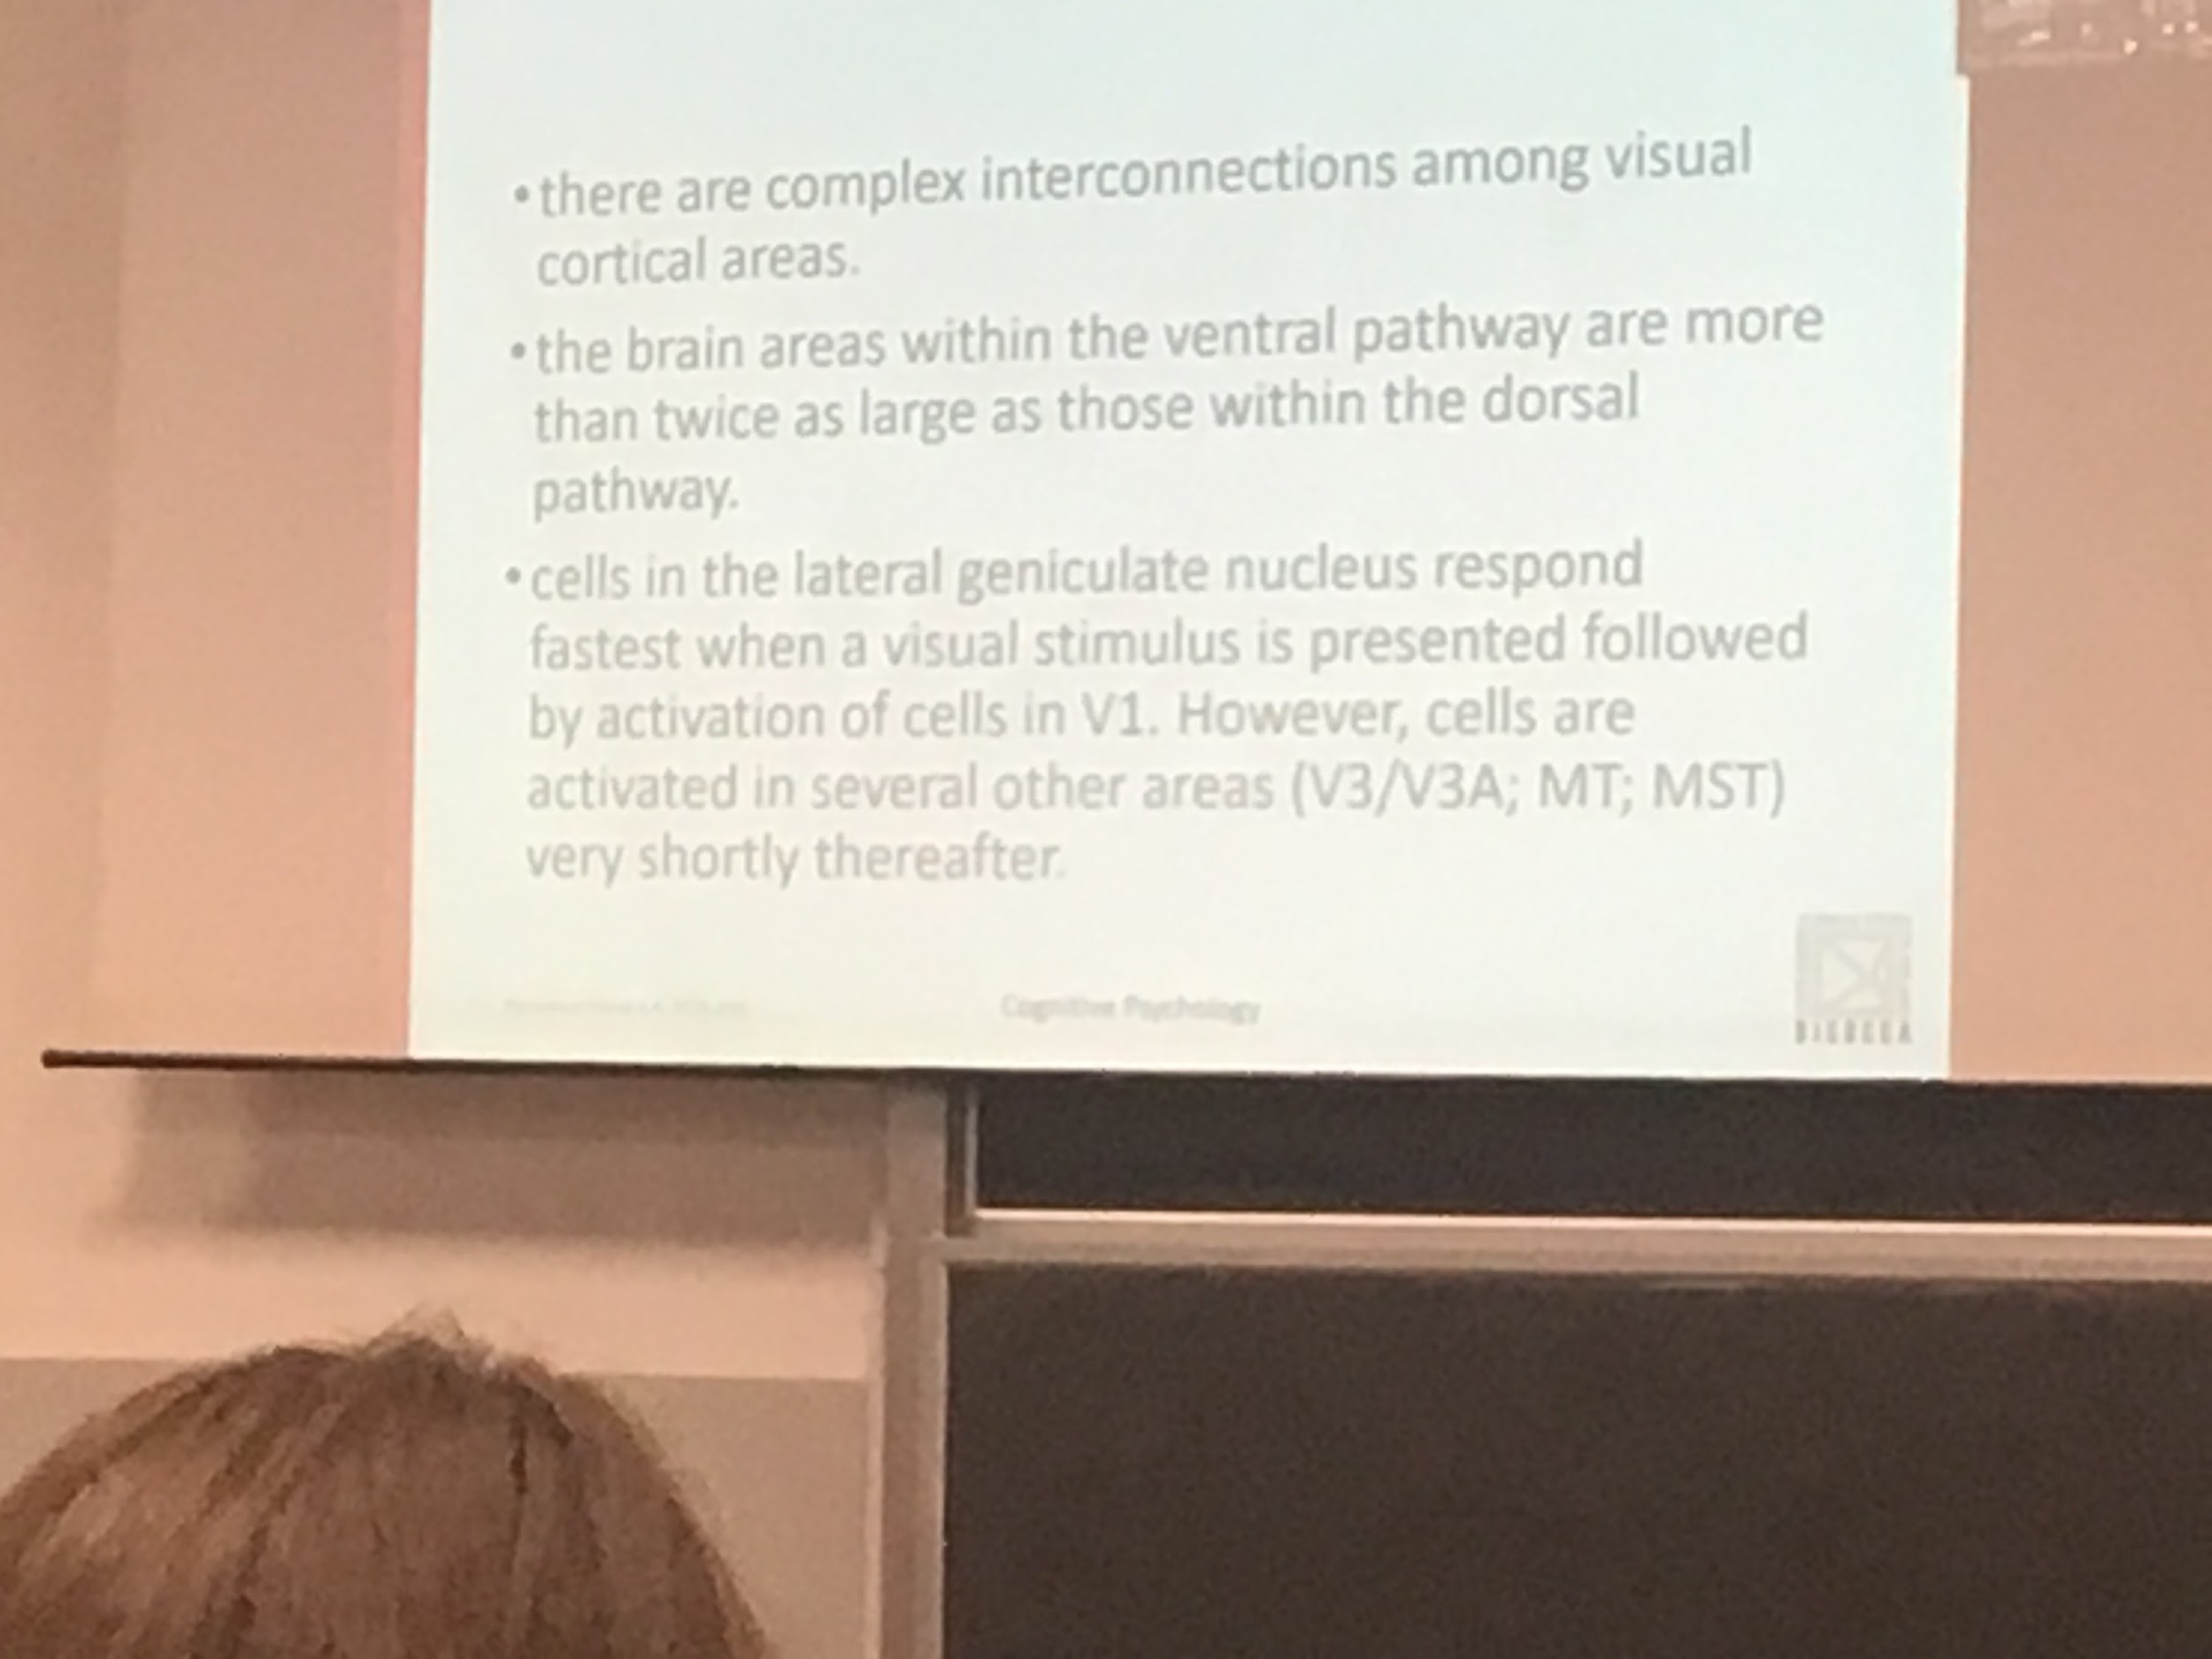

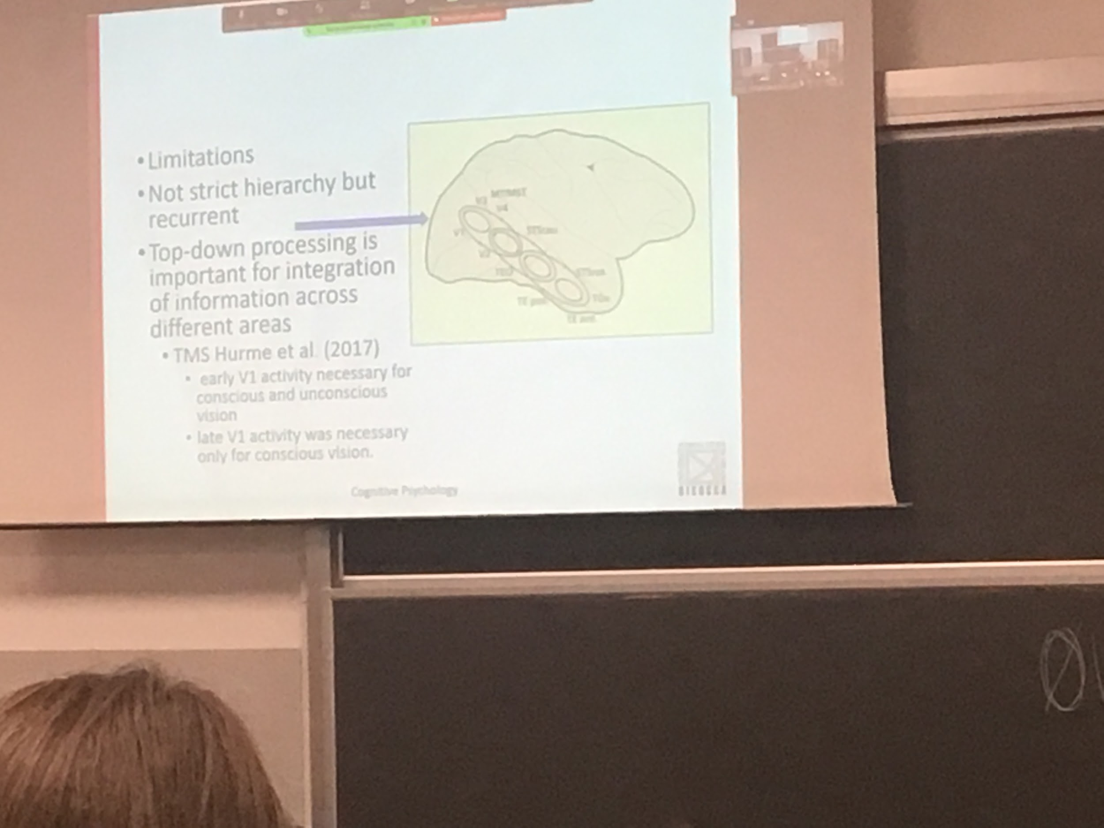

Bottom up: information from the eye to the cortexes

Top down: what we know (our memory) down to the first layer

There is a lot of backward projection that makes us interpret things that we see in different ways

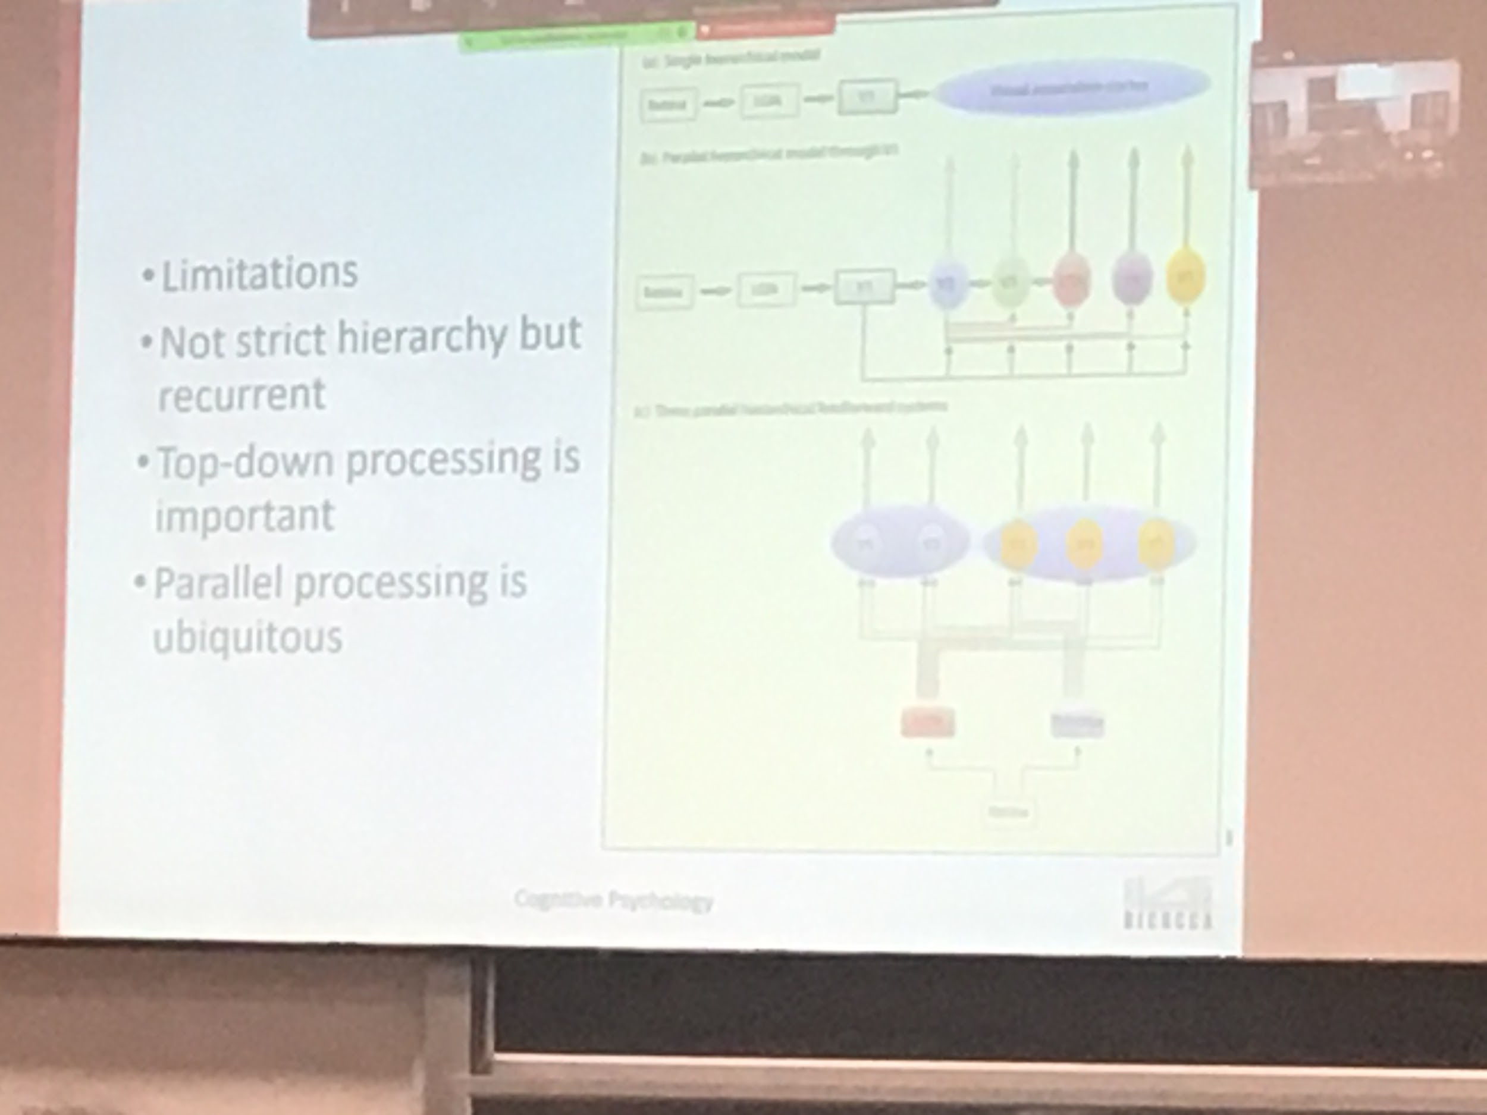

There is parallel processing, is not sequentially

Not easy to understand. It is not a strict module.

There is a huge interconnection between all the areas